Table of Contents

DAILY SIGHTSEEING TOURS AND ACTIVITIES IN ISTANBUL 2
HALF DAY TOURS 2
UNV/01 – Byzantine Visions 2
UNV/02 – Ottoman Visions 3
UNV/03 – Two Continents 4
UNV/04 – Bosphorus by Boat 5
UNV/05 – Istiklal Street 6
UNV/06 – Cooking Class 7
FULL DAY TOURS & EXCURSIONS 8
UNV/08 – Classical Tour 8
UNV/09 – Bosphorus and Asia 10
UNV/10 – Prince’s Islands 11
UNV/11 – Bursa 12
UNV/12 – Ephesus 13
ISTANBUL by NIGHT 14
UNV/13 - Istanbul by Night 14
UNV/14 – Dinner Cruise 15
UNV/15 – Whirling Derwishes 16
DAILY SIGHTSEEING TOURS AND ACTIVITIES IN CAPPADOCIA 18
UNV/21 – Classical Tour of Cappadocia 18
UNV/22 – Highlights of Cappadocia 20
UNV/23 – Wonders of Cappadocia 22
UNV/24 – Mysterious Cappadocia 23
UNV/25 – Hike in Cappadocia 24
UNV/26 – Hot Air Baloon 25
DAILY SIGHTSEEING TOURS AND ACTIVITIES IN IZMIR & KUSADASI 26
UNV/31 – Half Day Izmir 26
UNV/32 – Full Day Ephesus Tour 27
UNV/33 – Full Day Pergamum Tour 28
UNV/34 – Full Day Pamukkale Tour 29
UNV/35 – Full Day Visit Priene, Miletus & Dydima 30

DAILY SIGHTSEEING TOURS AND ACTIVITIES IN ISTANBUL

HALF DAY TOURS

UNV/01 – Byzantine Visions
Operates both privately and regularly.
Duration: 08:00 - 13:00
Notes:
- Year around guaranteed departure with no minimum number of guests requested.
- Departs: Daily
- Guests will be picked up and dropped off from/to their hotels.
- St. Sophia is closed on Monday. This day, they will visit Chora Museum (St. Savior in Chora)
- Grand Bazaar is closed on Sunday. This day, they can only visit the open section of the Bazaar
- Lunch is not included.

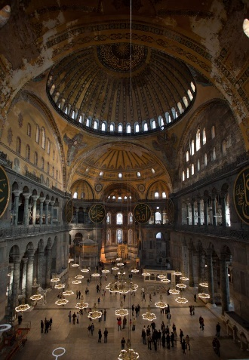
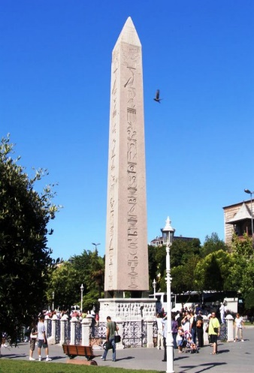
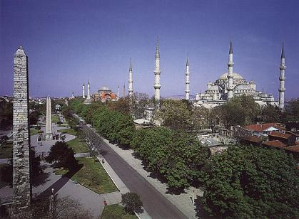
Drive to old town and visit Hippodrome Square, the scene of Chariot races and the center of Byzantine civic life, which was originally built by Roman Emperor Septimus in 203 AD. Then visit Blue Mosque, built in early 17th century and known as Blue Mosque because of its magnificent interior decoration with blue Iznik tiles. It is also unique in the world since it has 6 minarets.
Continue to St. Sophia Museum, built by Emperor Constantius is 360 AD. St. Sophia was for many centuries the world’s largest church and today is the fourth largest one after St. Paul’s in London, St. Peter’s in Rome and Duomo in Milan.
Throughout its Byzantine history, St. Sophia served as the cathedral of the city where emperors were crowned and victories celebrated.
After his conquest of the city in 1453, Sultan Mehmet II ordered for the building to be converted into a mosque by the addition of Islamic elements such as a mihrab, a mimber, minarets etc.
After having served this time as a mosque for 481 years, the building become a museum in 1934 by the order of Ataturk, the founder of the Republic of Turkey.
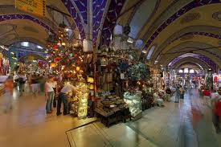
Last stop will be at famous historical Grand Bazaar, the largest “souk” covered oriental shopping mall in the world, where you will find 4,400 shops under one roof where each trade has its own street. There is a wide selection of leather, jewelry, antiques, copperware, souvenirs, and famous hand-made Turkish carpets displayed in this historical shopping center.

UNV/02 – Ottoman Visions
Operates both privately and regularly.
Duration: 13:00 - 18:00
Notes:
- Year around guaranteed departure with no minimum number of guests requested.
- Departs: Daily
- Guests will be picked up and dropped off from/to their hotels.
-Topkapi is closed on Tuesday
-Lunch is not included
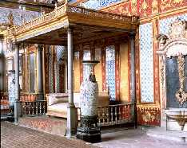
Visit Topkapi Palace, built by Sultan Mehmet II after the conquest of Istanbul in 15th century. The palace housed the sultans and their exotic entourage until mid-19th century. The complex is a group of structures which incorporates works from successive periods of Ottoman reign.

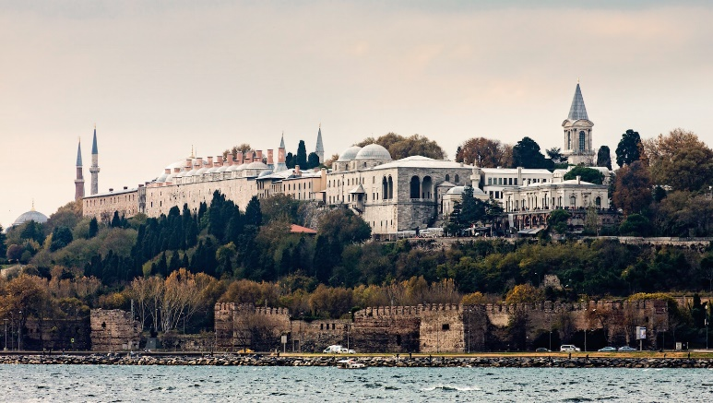
Today the museum displays priceless collections of the imperial treasury, numerous pieces of Chinese porcelain, traditional costumes of the sultans and their families and special section for the preservation of the relics of Prophet Mohammed.
After Topkapi, visit an Ottoman era mosque to enjoy art from Islamic period.

UNV/03 – Two Continents
Operates both privately and regularly.
Duration: 13:00 - 18:00
Notes:
- Year around guaranteed departure with no minimum number of guests requested.
- Departs: Daily
- Guests will be picked up and dropped off from/to their hotels.
-Beylerbeyi Palace is closed on Monday and Thursday
-Lunch is not included

Visit Beylerbeyi Palace, situated on the shore at the Asian end of the Bosphorus Bridge, which was built between 1861 and 1864 by Sultan Abdulaziz. The palace is a three- story structure set on terraced grounds planted with trees brought from all over the world. The interior was decorated in a style typical of the 19th century Europe and the original furniture is still in display. The building itself, constructed in the French Baroque style, is made of stone and marble. It was used by the Ottoman sultans as a summer residence.
Then, drive to Camlica Hill, highest hill in Istanbul, to enjoy the panoramic view of the city.
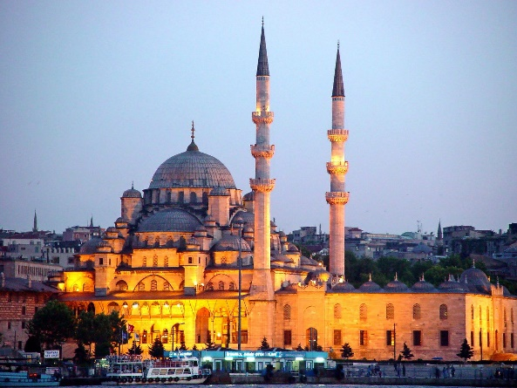
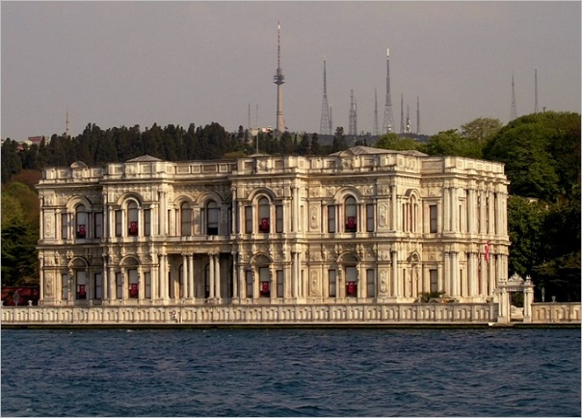

UNV/04 – Bosphorus by Boat
Operates both privately and regularly.
Duration: 08:00 - 13:00 OR 13:00 - 18:00
Notes:
- Year around guaranteed departure with no minimum number of guests requested.
- Departs: Daily
- Guests will be picked up and dropped off from/to their hotels.
- Lunch is not included

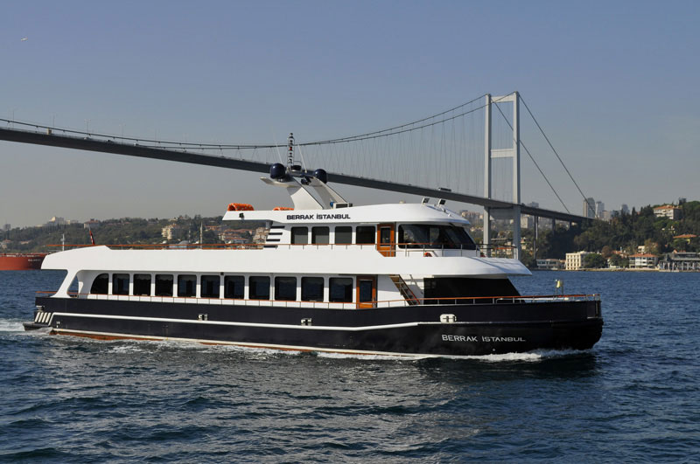
Drive to the pier in Eminonu for a short visit to historical Spice Market (Egyptian Bazaar). This bazaar was built in 1664 as a part of Yeni Mosque complex situated nearby and is named Egyptian Bazaar because spices and herbs brought from or via Egypt were sold in it.

Then, board a private boat for the cruise along the Bosphorus, a narrow strait between the continents of Europe and Asia connecting Black Sea to the Sea of Marmara. During the Byzantine and early Ottoman days, there was little settlement on both sides of the Bosphorus but as of the 18th century, it became the favorite place for the sultans and their entourage where they built their kiosks and waterside residence.

After, drive to the Asian Side of Istanbul via transcontinental Bosphorus Bridge, which is unique in the world since it connects Asia and Europe continents. The bridge was built in 1973, the 50th anniversary of the Republic of Turkey. Its length is 1.560 m (1,074 m over the sea) and height from the sea is 64 m. It is the fourth longest suspension bridge in the world.

UNV/05 – Istiklal Street
Operates privately only.
As this is a private tour, the departure and pick up times may differ.
Suggested durations will be as follows:
09:00 - 13:00 OR 13:00 - 18:00
Notes:
- Departs: Daily
- Guests will be picked up and dropped off from/to their hotels.
- Lunch is not included

Visit Istıklal Street which is located in Beyoglu & Taksim area; one of the most famous “pedestrian” avenues in Istanbul, visited by thousands of people every day. Located in the bohemian Beyoglu district, it is an elegant pedestrian street, approximately three kilometers long, which houses exquisite boutiques, music stores, bookstores, art galleries, cinemas, theaters, libraries, cafés, pubs, night clubs with live music, historical patisseries, chocolatiers and restaurants. The avenue, surrounded by the unique Greek architecture, starts from the medieval Genoese neighborhood around Galata Tower and ultimately leads up to Taksim Square.

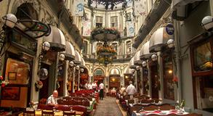
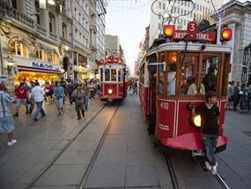

Cosmopolitan avenue is surrounded by an array of historically and politically significant buildings, such as the Cicek Pasaji (Flower Passage) where small, intimate restaurants and taverns are found; Balik Pazari (The Fish Market), The Roman Catholic Church of St.Antoine, designed in Italian Gothic style dated 1913. This red bricked affair replicates its ancestral model having been demolished to make way for Istiklal's tramway; The Aya Triada Church, a Greek Orthodox Church of the Holy Trinity overlooking Taksim square; The Roman Catholic Church of St. Mary Draperis, built in 1678; academic institutions established by various European nations such as Austria, France, Germany and Italy in the early 19th century; consulates (former embassies before 1923) of several nations including France, Greece, Russia, Spain, Sweden, the Netherlands and the United Kingdom.

UNV/06 – Cooking Class
Operates privately.
Duration: 09:30 - 14:30
Notes:
- Departs: Daily
- Guests will be picked up and dropped off from/to their hotels.

An absolutely wonderful surprise, when you visit Turkey, is the food. The variety and the simplicity of the recipes and the quality of the ingredients are the guarantee for delicious meals.

As frequently observed by Turks and foreigners, contemporary Turkish cuisine is the heir of the diverse culinary culture of the Ottoman Empire, extending over the eastern Mediterranean from the Balkans to the Middle East. The recipes are originating from the rich culinary traditions of this vast region, with emphasis on “living tradition” – a practical repertoire of familiar, well-tested, fine foods that can be prepared simply and tastefully for contemporary lifestyles, with easily available ingredients and in accordance with today’s cultural, aesthetic and hygienic standards.

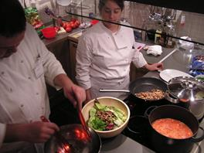
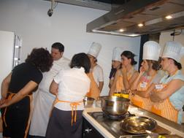

All courses are held by professional chefs and experts. After two hours of an interactive class by these experts, the participants will prepare a selected menu and eat for lunch.

FULL DAY TOURS & EXCURSIONS

UNV/08 – Classical Tour of Istanbul
Operates both privately and regularly.
Duration: 08:00 – 18:00
Notes:
- Year around guaranteed departure with no minimum number of guests requested.
- Departs: Daily
- Guests will be picked up and dropped off from/to their hotels.
- Topkapi Palace is closed on Tuesday. This tour does not operate on Tuesdays.
- St. Sophia is closed on Monday. This day, they will visit Chora Museum (St. Savior in Chora)
- Grand Bazaar is closed on Sunday. This day, they can only visit the open section of the Bazaar
- Basic lunch is included – without beverages.

Drive to old town and visit Hippodrome Square, the scene of Chariot races and the center of Byzantine civic life which was originally built by Roman Emperor Septimus in 203 AD. Then visit Blue Mosque, built in early 17th century and know as Blue Mosque because of its magnificent interior decoration with blue Iznik tiles. It is also unique in the world to have 6 minarets.

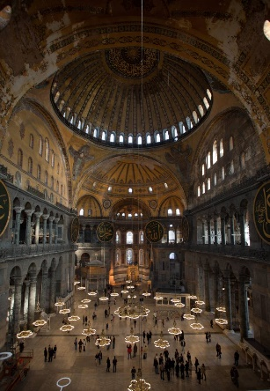
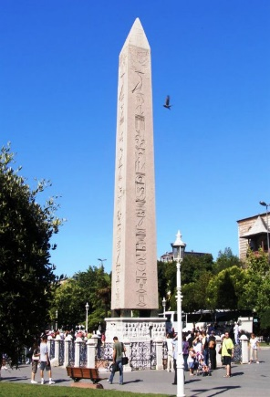
Continue to St. Sophia Museum, built by Emperor Constantius is 360 AD. St. Sophia was for many centuries the world’s largest church and today is the fourth largest one after St. Paul’s in London, St. Peter’s in Rome and Duomo in Milan.
Throughout its Byzantine history, St. Sophia served as the cathedral of the city where emperors were crowned and victories celebrated.

After his conquest of the city in 1453, Sultan Mehmet II ordered for the building to be converted into a mosque by the addition of Islamic elements such as a mihrab, a mimber, minarets etc.
After having served as a mosque for 481 years, the building become a museum in 1934 by the order of Ataturk, the founder of the Republic of Turkey.

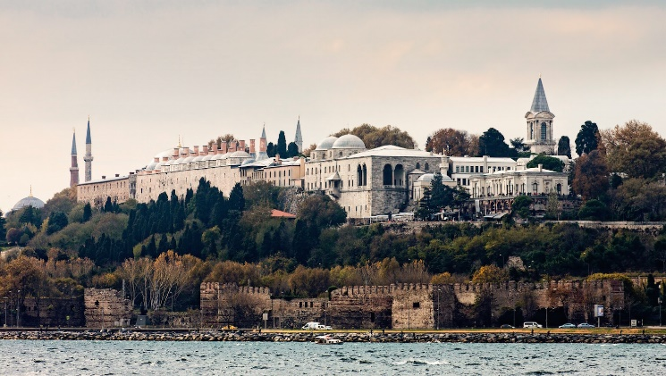
After lunch visit Topkapi Palace, built by Sultan Mehmet II after the conquest of Istanbul in 15th century. The palace housed the sultans and their exotic entourage until mid-19th century. The complex is a group of structures which incorporates works from successive periods of Ottoman reign. Today the museum displays priceless collections of the imperial treasury, numerous pieces of Chinese porcelain, traditional costumes of the sultans and their families and special section for the preservation of the relics of Prophet Mohammed.

Last stop will be at famous historical Grand Bazaar, the largest “souk” covered oriental shopping mall in the world, where you will find 4,400 shops under one roof where each trade has its own street. There is a wide selection of leather, jewelry, antiques, copperware, souvenirs, and famous hand-made Turkish carpets displayed in this historical shopping center.

UNV/09 – Bosphorus and Asia
Operates both privately and regularly.
Duration: 08:00 – 18:00
Notes:
- Year around guaranteed departure with no minimum number of guests requested.
- Departs: Daily
- Guests will be picked up and dropped off from/to their hotels.
- Beylerbeyi Palace is closed on Monday and Thursday
- Basic lunch is included.

Drive to pier in Eminonu for a short visit to historical Spice Market (Egyptian Bazaar). This bazaar was built in 1664 as a part of Yeni Mosque complex situated nearby and named Egyptian Bazaar because spices and herbs brought from or via Egypt were sold in it.
Then, board a private boat for the cruise along the Bosphorus, a narrow strait between the continents of Europe and Asia connecting Black Sea to the Sea of Marmara. In the Byzantine and early Ottoman days, there was little settlement on either sides of the Bosphorus but as of the 18th century, it became a favorite place for the sultans and their entourage where they built their kiosks and waterside residence.
Drive to the Asian Side of Istanbul via transcontinental Bosphorus Bridge, unique in the world connecting Asia and Europe continents. The bridge was built in 1973, the 50th anniversary of the Republic of Turkey. It’s length is 1.560 m (1,074 m over the sea) and height from the sea is 64 m. It is the fourth longest suspension bridge in the world.

Visit Beylerbeyi Palace, situated on the shore at the Asian end of the Bosphorus Bridge and built between 1861 and 1864 by Sultan Abdulaziz. The palace is a three-story structure set on terraced grounds planted with trees brought from all over world. The interior was decorated in a style typical of the 19th century Europe and the original furniture is still in display. The building itself, constructed in the French Baroque style, is made of stone and marble. It was used by the Ottoman sultans as a summer residence.
Then, drive to Camlica Hill, highest one in Istanbul, to enjoy the panoramic view of the city.

UNV/10 – Prince’s Islands
Operates both privately and regularly.
Duration: 08:00 – 18:00
Notes:
- Year around guaranteed departure with no minimum number of guests requested.
- Departs: Daily
- Guests will be picked up and dropped off from/to their hotels.
- Basic lunch is included.
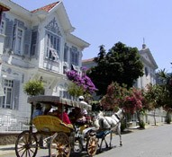
Board the private boat from the pier of Ciragan Palace Kempinski for 90-minute sail to Prince’s Islands. There are nine islands, and we disembark at the largest and most famous one called BUYUK ADA.
During the Byzantine days, the islands collectively formed a religious center with many monasteries. The name “Prince’s Islands” derives from the princes sent there in exile. Those were the ones regarded as pretenders to the throne.
In the afternoon, tour of the island by horse carriages (phaeton), visit Ayia Yorgi Church and Monastery dating back to 6th century and spend some free time at the local market.

UNV/11 – Bursa
Operates both privately and regularly.
Duration: 08:00 - 22:00
Notes:
- A minimum of eight (8) participants are required for this tour.
- Year around guaranteed departure.
- Departs: Daily
- Guests will be picked up and dropped off from/to their hotels.
- Basic lunch is included.
- This tour is available on Mondays, Thursdays & Saturdays. In the event the cable car is closed due to weather conditions, Cinaralti is substituted for Uludağ
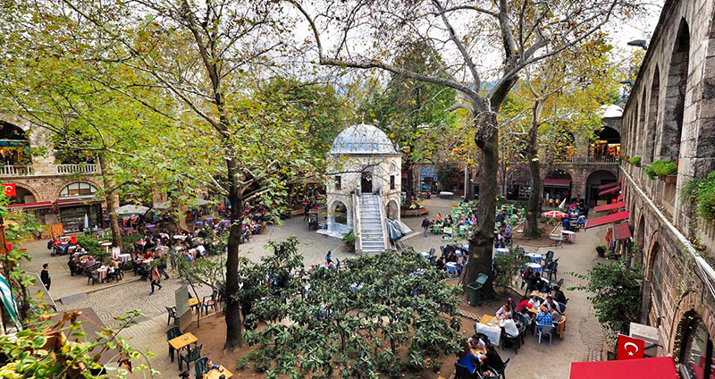
Travel to Yalove by ferry, then by luxury coach to the city of Bursa, which dates back to the 2nd century B.C. The first capital of the Ottoman Empire; Bursa is one of the greatest treasure houses of Islamic architecture. Firstly visit the Green Mosque and the neighboring Green Mausoleum, both world-renowned for their superb tile decorations, as well as the late 14th century Great Mosque and the Koza Han, which was the center of Bursa’s flourishing silk trade for centuries. As the capital of Turkey’s silk production and importation, Bursa was also the home of the skilled artisans who produced kaftans, pillows, embroidery and other silk products for the Ottoman palaces until the 17th century. Afterwards, enjoy a cable car ride up the slopes of Mount Olympus, in Turkish, Uludağ, or if the cable car is not running, take in the panoramic views from beneath the more than 1,000 year-old plane tree that gives Cinaralti its name. Lunch is at one of Bursa’s most highly-regarded traditional Turkish restaurants, the Darüzziyafe, where we will enjoy the finest authentic Ottoman cuisine in a historic setting, where Sultan Murat the Second once dined.

UNV/12 – Ephesus
Operates both privately and regularly.
Duration: 08:00 – 22:00
Notes:
- A minimum of eight (8) participants are required for this tour.
- Year around guaranteed departure with no minimum number of guests requested.
- Departs: Daily
- Guests will be picked up and dropped off from/to their hotels.
- Basic lunch is included.

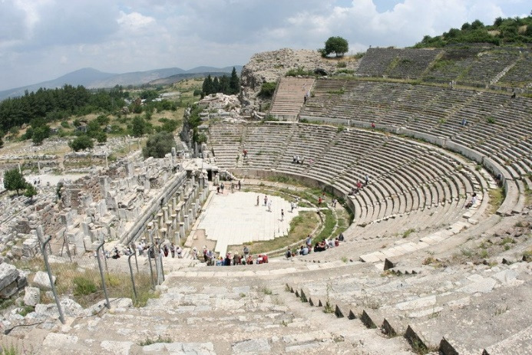
Catch an early flight to the city of Izmir on the Aegean coast, then drive south to the antique city of Ephesus. This is one of the world’s richest and most rewarding archaeological sites with impressive ruins dating from the Classical Greek, Hellenistic, Roman and early Byzantine periods. It is also closely associated with the beginnings of the Christian faith.

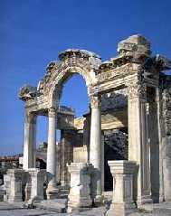

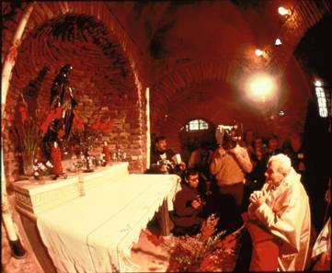
In addition to being the city to which the Letters to the Ephesians were written, St. John and St. Paul both visited the city, and the Virgin Mary herself is said to have spent her last days nearby. Among the highlights of our tour of Ephesus will be the antique theatre, the famed Library of Celsus, the brothel, the vast Basilica of St. John, the Mosque of Isabey, the Temple of Artemis (one of the Seven Wonders of the Ancient World) and a group of recently excavated early Byzantine mansions that feature incredibly well-preserved floor mosaics and frescoes. At Ephesus, the past comes to life in a pageantry of architectural and artistic marvels; the like of which cannot be found almost anywhere else in the world. Finally make a short pilgrimage to the House of the Virgin Mary, which stands high on a mountainside overlooking the Aegean Sea and the Greek island of Samos.

ISTANBUL by NIGHT

UNV/13 - Istanbul by Night
Operates regularly.
Duration: 18:30 – 22:30
Notes:
- Year around guaranteed departure with no minimum number of guests requested.
- Departs: Daily
- Guests will be picked up and dropped off from/to their hotels.

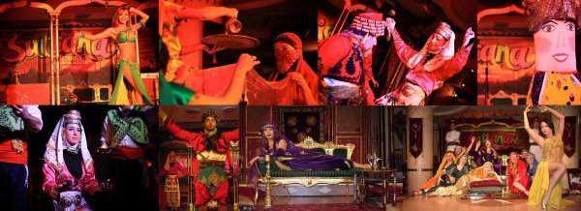
Pick up from the hotel and transfer to the Sultanas Night Club located at the center of New Town, within few minutes walking distance to the Taksim Square.
The night club is decorated in Ottoman style with authentic ornaments creating warm and entertaining atmosphere.
The rich show of the night club includes traditional folk dancing from different parts of Turkey and belly dancers.
The night club opens at 20:00 (8pm) and show starts at 21:00 (9pm).
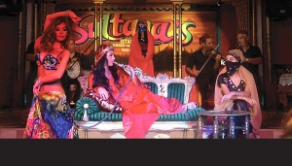
The 2-hour show includes following;
- The first “belly dance” show
- Folk dance group from Aegean Region (Western Turkey)
- The second “belly dance” show
- Aşuk-Maşuk Show (Muppet show performed by two live dancers)
- The third “belly dance” show
- Turkish Dance Music
At the end of the show, guests will be transferred back to their hotels.

UNV/14 – Dinner Cruise
Operates regularly.
Duration: 18:30 – 23:59
Notes:
- Year around guaranteed departure with no minimum number of guests requested.
- Departs: Daily
- Guests will be picked up and dropped off from/to their hotels.

Bosphorus, one of the most exquisite water ways in the world, is a narrow strait (31 km long) between the continents of Europe and Asia connecting Black Sea and the Sea of Marmara. In Byzantine and early Ottoman days, there was little settlement on either side of Bosphorus but as of the 18th century it became a favorite place for the sultans and their entourage where they built their villas and waterside residences.
During the cruising along the Asiatic and European shores of the Bosphorus, the guests enjoy the delightfully surprising mixture of the past and the present; the beautiful Ottoman time villas (yali) and historical fortresses that have survived and the modern villas complementing each other.
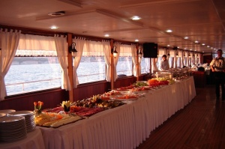
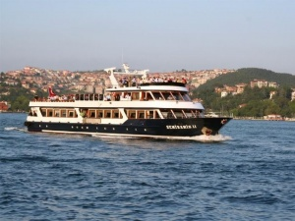

UNV/15 – Whirling Derwishes
Operates regularly.
Duration: 18:30 – 21:00
Notes:
- Year around guaranteed departure with no minimum number of guests requested.
- Departs: Daily
- Guests will be picked up and dropped off from/to their hotels.
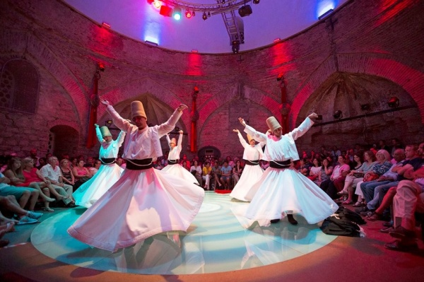
Depart from the hotel to watch the ceremony of Whirling Dervishes called “Sema”.
Sema ceremony is a mystical journey of man’s spiritual ascent through mind and love to the "Perfect". A Sufi order founded in Konya, Turkey Mevlevi Order was established by the followers of Mevlana Celaledding Rumi, a 13th century Islamic poet and theologian. They are known as the Whirling Dervishes due to their famous practice of whirling as a form of dhikr (remembrance of God). Dervish is a common term for an initiate of the Sufi path; the whirling is part of the formal Sema ceremony and the participants are properly known as semazens.
Turning towards the truth, the follower grows through love, deserts his ego, finds the truth, and arrives at the "Perfect". He then returns from this spiritual journey as a man who has reached maturity and a greater perfection, able to love and to be of service to the whole of creation.
Mevlana Celaleddin Rumi has said in reference to Sema:
“Come, come, whoever you are,
Wanderer, worshipper, lover of leaving,
Ours is not a caravan of despair.
Even if you have broken your vows a thousand times
It doesn’t matter
Come, come yet again, come”

This unique show will have a memorable remark from the beginning where the Sema’s bow each other and whirl as the representatives of the moon and the sun separately to the end where they recite prays from the Qu’ran and complete the Sema.

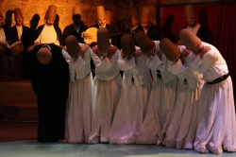
HODJAPASHA Culture Center is located at the center of Historical peninsula of Istanbul and was converted from a 550 years old historical turkish bath called Hocapasa Hamami in 2008. It was originally built by Hoca Sinan Pasa who was a teacher and later vizier to Fatih Sultan Mehmet during 1470's. It was a double bath for both men and women. It was comparatively a big bath with high dome, made of cut stone and also corner walls were designed like a peacock tail.

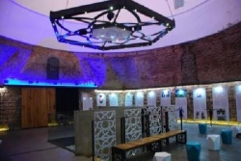
This building served as a Turkish bath till 1988. Location of the area is called Sirkeci which is next to Topkapı Palace Walls , Sirkeci Train Station formerly known also as Orient Express Train Station and Sultanahmet Area. Hodjapasha Culture Center has two sections. First is an exhibition and foyer area. The other section is performance area which has a circular glass dance floor and a musician stage. Spectator seats are located around circular dance floor and has a capacity of 220 guests. Perfect lighting and beautiful decoration turns this historical building to a mystic place.

DAILY SIGHTSEEING TOURS AND ACTIVITIES IN CAPPADOCIA

UNV/21 – Classical Tour of Cappadocia
Operates both privately and regularly.
Duration: pick up - 09:30/10:00 drop off: 16:30/17:30
Notes:
- Year around guaranteed departure with no minimum number of guests requested.
- Departs: Daily
- Guests will be picked up and dropped off from/to their hotels.
- Basic lunch included.
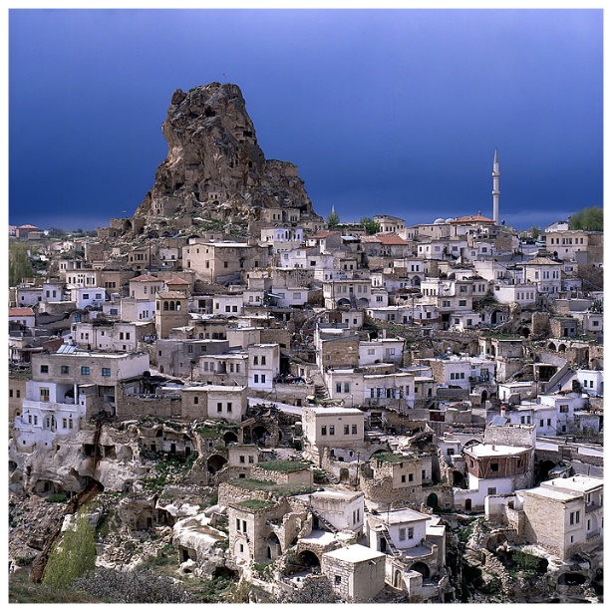
Firstly, you will visit Devrent Imagination Valley and walk through this lunar landscape. Then visit Pasabag in Cappadocia, located on the road coming from Goreme. Highly remarkable earth pillars can be seen here, in the middle of a vineyard, hence the name of the place, which means: the Pacha's (Paşa) vineyard. Pacha means “General” in Turkish and it is a very common nick name. This site is also called Monk’s Valley. The name was derived from some cones carved in tuff stones which stands apart. Currently, there is a vineyard and a number of tuff cones standing right next to the road.

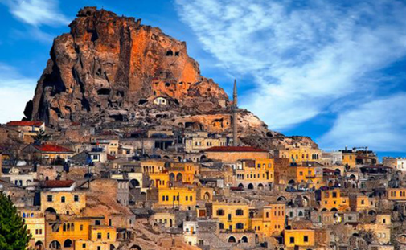
Uchisar Rock-Castle, (the highest point in the region, Esentepe (a panoramic view of Goreme valley) and Goreme Open Air Museum which consists of steep cliffs and many hidden churches dating from second half of 9th century. (Rock-cut churches, frescoes, monastery)

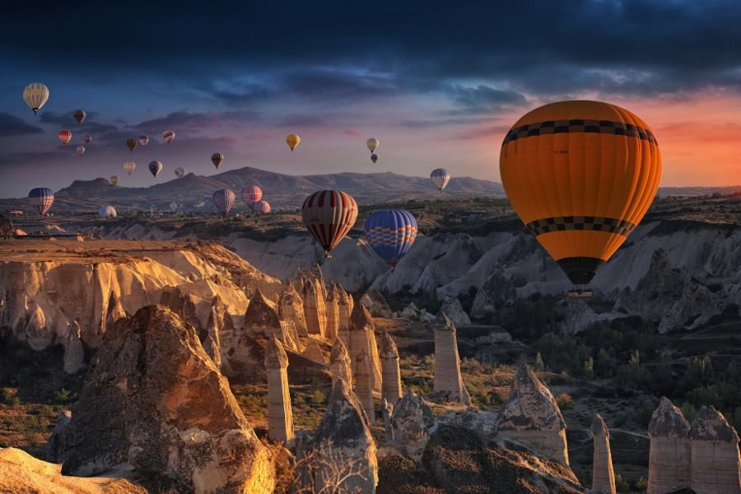
Continue to visit the villages of Avanos. It is a small town famous for its pottery. It is built along the banks of Kizilirmak (Hayls River), the longest river originated and ending within the borders of Turkey with 842 miles of length. Those who want may also enjoy famous “testi kebab” as well.

UNV/22 – Highlights of Cappadocia
Operates privately.
Duration: pick up - 09:30/10:00 drop off: 16:30/17:30
Notes:
- Year around guaranteed departure with no minimum number of guests requested.
- Departs: Daily
- Guests will be picked up and dropped off from/to their hotels.
- Basic lunch included.

Uchisar Rock-Castle, (the highest point in the region, Esentepe (a panoramic view of Goreme valley. This castle is like none you have ever seen before. Unlike the large walls of classic European castles, Uchisar looks like a maze of carved rooms. Venturing inside, you will be able to reach the highest point of the castle.

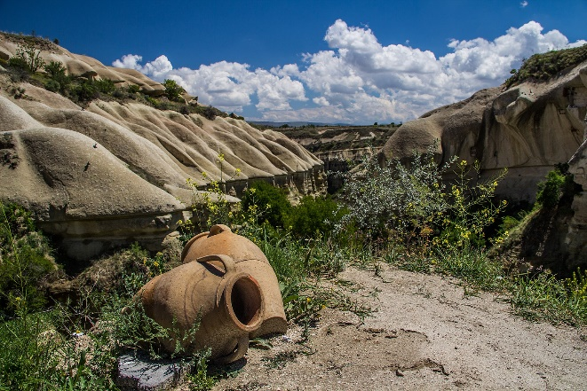
From there you will get to enjoy the best views of the Pigeon valley. This is the highest point in the entire area. Visit Goreme Open Air Museum which consists of steep cliffs and many hidden churches dating from second half of 9th century. (Rock-cut churches, frescoes, monastery)

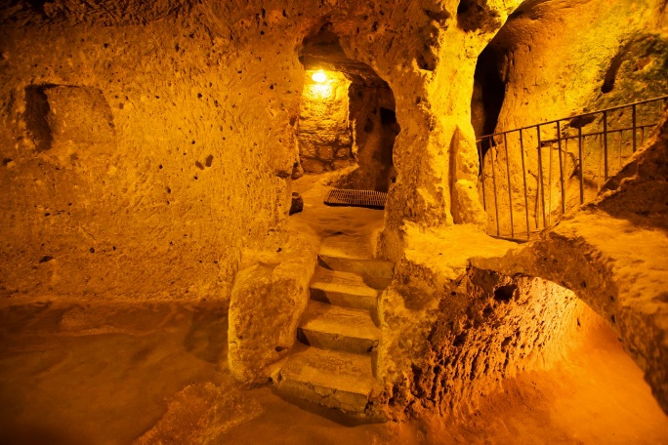
Multi- level Underground City of Kaymakli, is one of the largest underground cities in Cappadocia with eight stories. In the area there are 36 underground cities and the original establishment is not known. Some dated back to Hittites (5C BC) and some as late as 6th C AD.
These underground cities were used by early Christians escaping from persecution until 7th century. These underground cities cannot be noticed from the ground level. They carved air shafts as deep as 85 meters into the rock and

then made holes laterally at different levels in all directions. They hewed an elaborate system of the surface. They dug dwellings, bathrooms, kitchens, dinning-halls, storage rooms, wine cellars, chapels, graves and suchlike. Entrances at the surface level were also camouflaged.
Underground City of Kaymakli covers an area of approximately 4 meter-square

Continue with Goreme Open Air Museum which consists of steep cliffs and many hidden churches dating from second half of 9th century. (Rock-cut churches, frescoes, monastery)
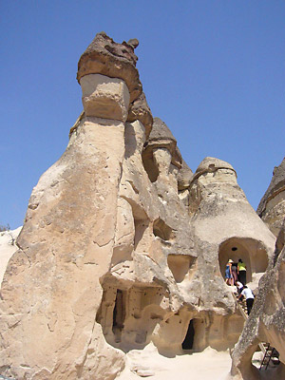
Visit Pasabag in Cappadocia, located on the road coming from Goreme. Highly remarkable earth pillars can be seen here, in the middle of a vineyard, hence the name of the place, which means: the Pacha's vineyard. Pacha means “General” in Turkish and it is a very common nick name. This site is also called Monk’s Valley. The name was derived from some cones carved in tuff stones which stands apart. Currently, there is a vineyard and a number of tuff cones standing right next to the road.

Continue to visit the villages of Avanos. It is a small town famous for its pottery. It is built along the banks of Kizilirmak (Hayls River), the longest river originated and ending within the borders of Turkey with 842 miles of length. Those who want may also enjoy famous “testi kebab” as well.

UNV/23 – Wonders of Cappadocia
Operates privately.
Duration: pick up - 09:30/10:00 drop off: 16:30/17:30
Notes:
- Year around guaranteed departure with no minimum number of guests requested.
- Departs: Daily
- Guests will be picked up and dropped off from/to their hotels.
- Basic lunch included.

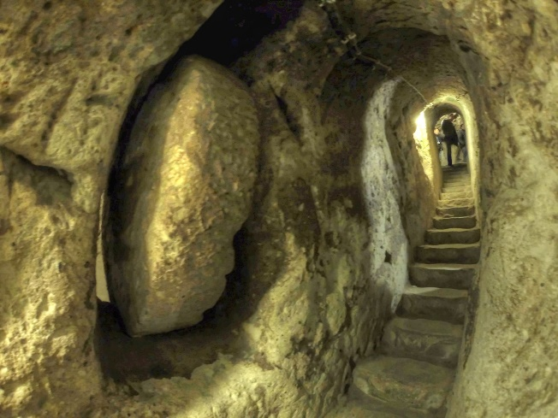
The Derinkuyu underground city is an ancient multi-level underground city in the Derinkuyu district in Nevşehir Province, Turkey, extending to a depth of approximately 60 meters. It is large enough to have shelter as many as 20,000 people together with their livestock and food stores. It is the largest excavated underground city in Turkey and is one of several underground complexes found throughout Cappadocia. The underground city at Derinkuyu could be closed from the inside with large stone doors. Each floor could be closed off separately.
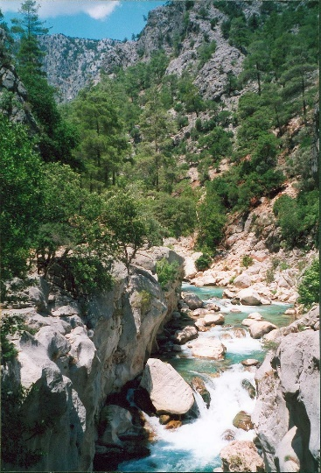

Ihlara Valley, is a 16 km long gorge cut into volcanic rock in the southern part of Cappadocia, following several eruptions of Mount Erciyes. The Melendiz Stream flows through the valley. Ihlara Valley consists of 14km along the north-south Melendi River, which runs from Selime to Ihlara village. Sixteen of the valley’s 105 churches are open to visitors, and most of these are within 1km of the official valley entrance in Ihlara.

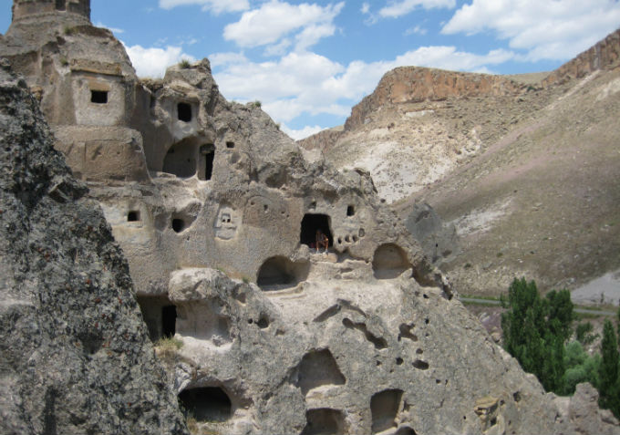
While in Ihlara, visit Belisirma Village inside Ihlara Valley, which is located in the centre as well as Güzelyurt Village, which was a prosperous Ottoman-Greek town specializing in farming and goldsmithing.

UNV/24 – Mysterious Cappadocia
Operates both privately and regularly.
Duration: pick up - 09:30/10:00 drop off: 16:30/17:30
Notes:
- Year around guaranteed departure with no minimum number of guests requested.
- Departs: Daily
- Guests will be picked up and dropped off from/to their hotels.
- Basic lunch included.

Multi- level Underground City of Kaymakli, is one of the largest underground cities in Cappadocia with eight stories. In the area there are 36 underground cities and the original establishment is not known. Some dated back to Hittites (5C BC) and some as late as 6th C AD.
These underground cities were used by early Christians escaping from persecution until 7th century. These underground cities cannot be noticed from the ground level. They carved air shafts as deep as 85 meters into the rock and

then made holes laterally at different levels in all directions. They hewed an elaborate system of the surface. They dug dwellings, bathrooms, kitchens, dinning-halls, storage rooms, wine cellars, chapels, graves and suchlike. Entrances at the surface level were also camouflaged.
Underground City of Kaymakli covers an area of approximately 4 meter-square

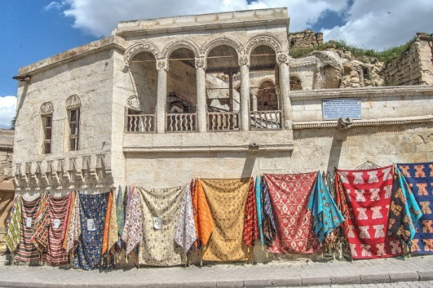
Soğanlı Valley and Sinasos (Mustafapaşa) Village are the following stops.
Former name of Mustafapaşa during the Ottoman Empire era was Sinasos. It had a mixed population. Greeks and Karamanlides (Turkish speaking Christians) constituted the majority of the population and Muslim Turks constituted the rest. Although situated far from the seas Sinasiotes (Greeks from Sinasos) who temporarily migrated to İstanbul, were known to be the traders of seafood and especially caviare. Then visit Taskinpasa Village to see the ancient ruins of stonemasonry from mid 14th century.

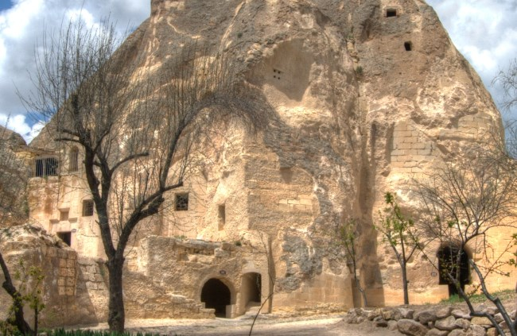
Keslik Monastery dates from 7th century to 13th century. It houses 14 man made churches that are carved into rocks. You can see the frescoes on ceilings and walls, depicting stories from the Bible.

UNV/25 – Hike in Cappadocia
Operates privately.
Duration: pick up - 09:30/10:00 drop off: 16:30/17:30
Notes:
- Year around guaranteed departure with no minimum number of guests requested.
- Departs: Daily
- Guests will be picked up and dropped off from/to their hotels.
- Basic lunch included.

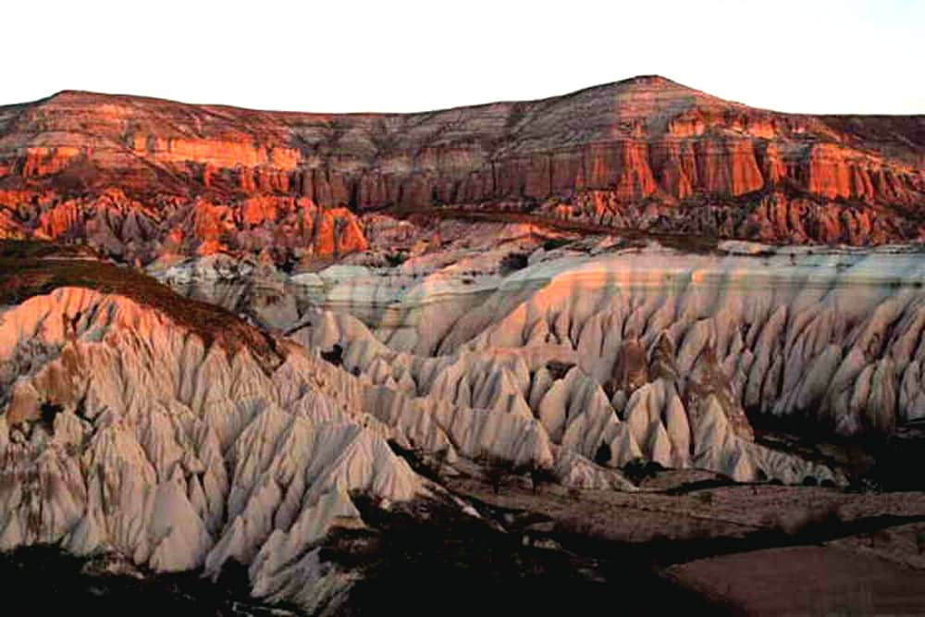

Red Valley, also known as Kızılçukur Valley, is a 15 minute drive from Göreme, close to Ortahisar. It is a wonderful spot to watch the sunset as rare red tuff rocks makes the sunset even better. You can hike through little paths, see small cave churches and vineyards.

Visit Cavusin village, a Greek town whose history goes back to the Early Christian Period. The rock cut buildings have collapsed because of erosion but the churches are still in place and being used as dovecotes. Then visit Goreme Valley consisting of steep cliffs and many hidden churches dating from second half of 9th century.

UNV/26 – Hot Air Baloon
Operates regularly.
Duration (time spent on air): 1 hour
Pick up: Hotel pick up times vary in between 03:30 to 05:00 AM
Notes:
- Year around guaranteed departure with no minimum number of guests requested.
- Departs: Daily
- Guests will be picked up and dropped off from/to their hotels.

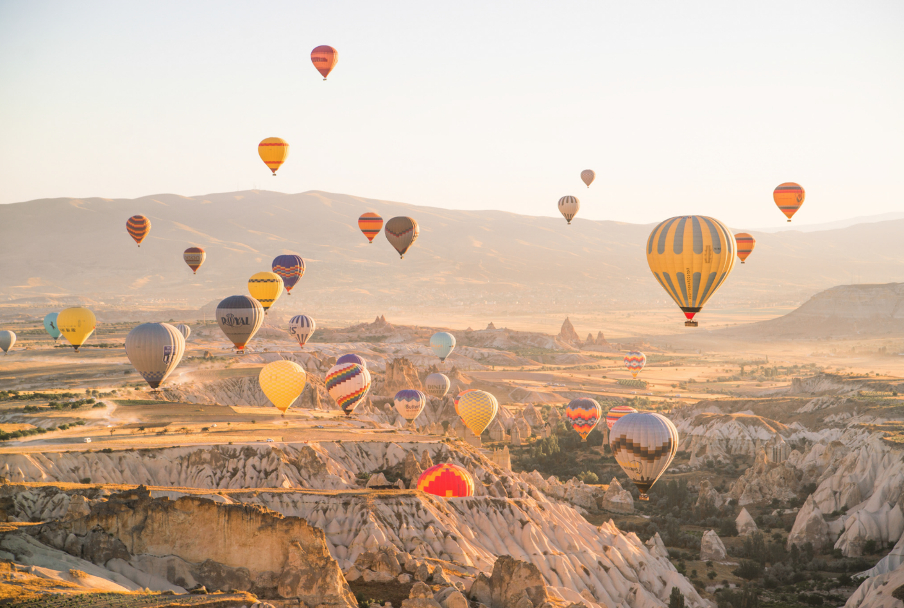
Cappadocia is known around the world as one of the best places to fly with hot air balloons. The spectacular surrealistic landscapes combined with excellent flying conditions allow the balloons to gently drift over and between fairy chimneys, pigeon houses hewn into the unique rock formations, orchards and vineyards – through impressive valleys, each with distinctive rock formations, colors and features – and then float up over rippled ravines for breathtaking views over the region.

UNV/27 – Whirling Dervishes
Operates regularly.
Duration: 17:30 – 19:30
Notes:
- Year around guaranteed departure with minimum number of 5 guests requested.
- Departs: Daily
- Guests will be picked up and dropped off from/to their hotels.
The Sema (Derwish) Ceremony represents mystical journey of man’s spiritual ascend through love, deserts his ego, finds the truth and arrives to the “Perfect”. Then he returns from this spiritual journey as a man who reached maturity and a greater perfection, so as to love and to be of service to the whole creation, to all creatures without discriminating in regard to belief, class or race. Ceremony being a part of the traditions and beliefs in Turkish history, is developed with the Rumi's inspiration. We will pick you up from your hotel, the ceremony starts everyday 18.00 and you can witness during 1 hour. After that we will drop you back to the hotel.

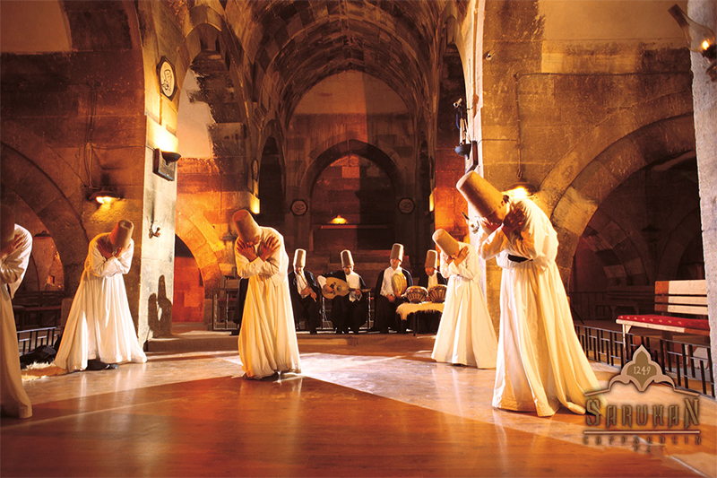

DAILY SIGHTSEEING TOURS AND ACTIVITIES IN IZMIR & KUSADASI

UNV/31 – Half Day Izmir
Operates both privately and regularly.
Duration: pick up - 09:30/10:00 drop off: 12:30/13:00
Notes:
- Year around guaranteed departure with minimum number of 5 guests requested.
- Departs: Daily
- Guests will be picked up and dropped off from/to their hotels.
- Lunch is not included
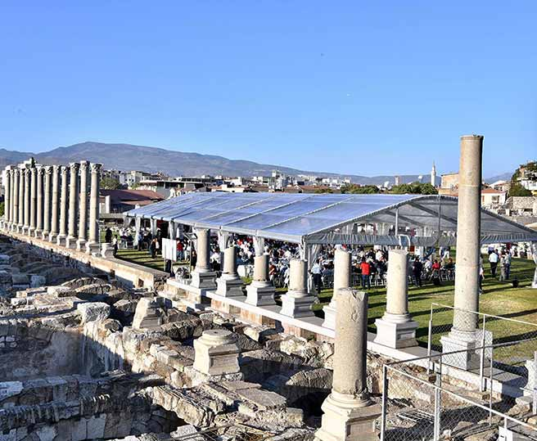
Pick up from your hotel and morning or afternoon visit the ancient Agora the remains of the ancient agora of Smyrna constitute today the space of İzmir Agora Museum in İzmir's Namazgah quarter, although its area is commonly referred to as "Agora" by the city's inhabitants. Situated on the northern slopes of the Pagos hills, it was the commercial, judicial and political nucleus of the ancient city, its center for artistic activities and for teaching.
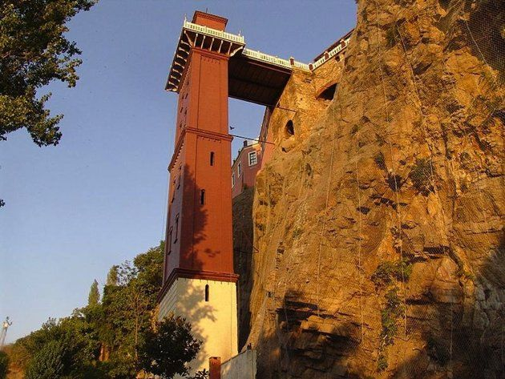
Visit Old Elevator Building, overlooking the city of Izmir, the "Pearl of The Aegean Sea".
Then visit the Archaeological and Ethnographical Museums. The Izmir Archeology Museum is one of the first built in Western Anatolia and contains a collection of artifacts of the Aegean Region. The museum's collection has been categorized as a regional museum rather than a local one because of the importance of its collection. The Museum is located in Konak, in the central part of the city. It is within walking distance of Konak Square. Return back to your hotel after the tour. Drop off at your hotel.

UNV/32 – Full Day Ephesus Tour
Operates both privately and regularly.
Duration: pick up - 09:30/10:00 drop off: 19:00/19:30
Notes:
- Year around guaranteed departure with no minimum number of guests requested.
- Departs: Daily
- Guests will be picked up and dropped off from/to their hotels.
- A basic lunch is included
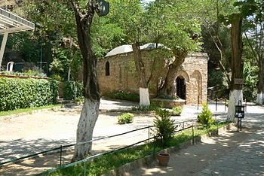
Pick up from your hotel and leave for Ephesus, the veritable cradle of early Christianity. Visit the House of The Virgin Mary where she supposedly spent her later days. Catholic pilgrims visit the house based on the belief that Mary, the mother of Jesus, was taken to this stone house by Saint John and lived there for the remainder of her earthly life. The shrine has merited several papal Apostolic Blessings and visits from several Popes John Paul II and Benedict XVI.
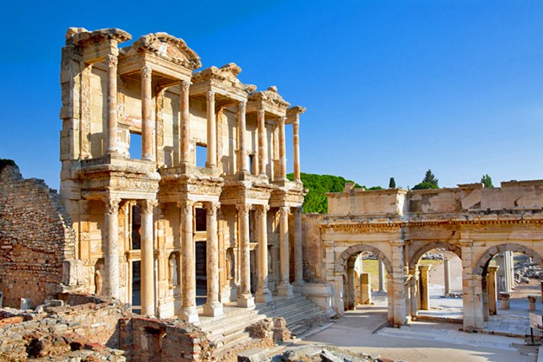
Proceed to Ephesus and see the spectacular ruins from the period of St. Paul, some of which have only recently been excavated. See the Odeon, the Bouleterion, Fountains, the Temples, the Brothel, the Library, the Agoras, the Great Theatre, the Roman Baths, the Gymnasiums. may ultimately derive from Hittite Apasa was an ancient Greek city on the coast of Ionia, three kilometers southwest of present-day Selçuk in İzmir Province, Turkey. It was built in the 10th century BC on the site of the former Arzawan capital by Attic and Ionian Greek colonists. During the Classical Greek era it was one of the twelve cities of the Ionian League. The city flourished after it came under the control of the Roman Republic in 129 BC.
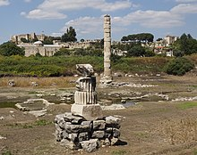
After lunch visit the Temple of Artemis (one of the Seven Wonders of the ancient world). The Temple of Artemis or Artemision also known less precisely as the Temple of Diana, was a Greek temple dedicated to an ancient, local form of the goddess Artemis (associated with Diana, a Roman goddess). It was loca ted in Ephesus (near the modern town of Selçuk in present-day Turkey). It was completely rebuilt twice, once after a devastating flood and three hundred years later after an act of arson, and in its final form was one of the Seven Wonders of the Ancient World. By 401 AD it had been ruined or destroyed.[1] Only foundations and fragments of the last temple remain at the site. Return back to your hotel after the tour. Drop off at your hotel.

UNV/33 – Full Day Pergamum Tour
Operates both privately and regularly.
Duration: pick up - 09:30/10:00 drop off: 19:00/19:30
Notes:
- Year around guaranteed departure with minimum number of 2 guests requested.
- Departs: Daily
- Guests will be picked up and dropped off from/to their hotels.
- A basic lunch is included
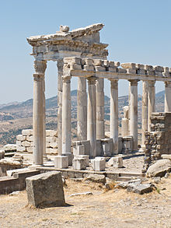
Pick up from your hotel and drive to Pergamon. During the Hellenistic period, it became the capital of the Kingdom of Pergamon under the Attalid dynasty in 281–133 BC, who transformed it into one of the major cultural centres of the Greek world. Many remains of its impressive monuments can still be seen and especially the outstanding masterpiece of the Pergamon Altar. Pergamon was the northernmost of the seven churches of Asia cited in the New Testament Book of Revelation.

Visit the Acropolis, the Temple Of Athena, the famous Library, the Royal Palaces, the Temple Of Trojan, the steepest Theatre of the world, the Temple Of Dionysos, the Altar Of Zeus (Seat of Satan), and the view of the Red Basilica (St. John’s church). Lunch in town. Visit the ruins of Asclepion (Medical Center of the ancient world). Return back to your hotel after the tour. Drop off at your hotel

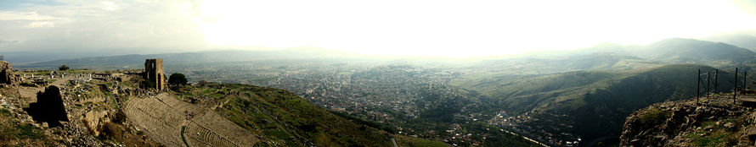

UNV/34 – Full Day Pamukkale Tour
Operates both privately.
Duration: pick up - 09:00/09:30 drop off: 20:00/20:30
Notes:
- Year around guaranteed departure on private basis
- Departs: Daily
- Guests will be picked up and dropped off from/to their hotels.
- A basic lunch is included
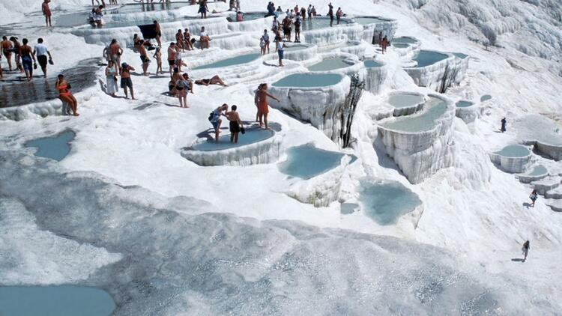
Pick up from your hotel or Izmir airport and drive to Pamukkale (the cotton castle) one of the most spectacular sites. See the wonderful formations of the travertine and watch the cataracts falling into basins at the bottom of the mountain. Walk around the ancient city Hierapolis, the Monument and Thermal Baths. See the architectural genius of the Theatre, the magnificently well preserved Necropolis and the world wide famous "Devil’s Hole". Year-round swimming possibility in the natural hot spring pool.

Hierapolis was an ancient Greek city located on hot springs in classical Phrygia in southwestern Anatolia. Its ruins are adjacent to modern Pamukkale in Turkey and currently comprise an archaeological museum designated as a UNESCO World Heritage Site.

The hot springs have been used as a spa since the 2nd century BC, with many patrons retiring or dying there. The large necropolis is filled with sarcophagi, most famously that of Marcus Aurelius Ammianos, which bears a relief depicting the earliest known example of a crank and rod mechanism.
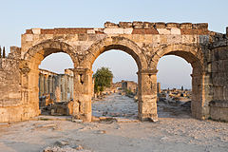
Part of the archeological site of Hierapolis
The great baths were constructed with huge stone blocks without the use of cement and consisted of various closed or open sections linked together. There are deep niches in the inner section, including the bath, library, and gymnasium.

Return back to Izmir after the tour. Drop off at your hotel or Izmir airport.

UNV/35 – Full Day Visit Priene, Miletus & Dydima
Operates both privately.
Duration: pick up - 09:00/09:30 drop off: 20:00/20:30
Notes:
- Year around guaranteed departure on private basis
- Departs: Daily
- Guests will be picked up and dropped off from/to their hotels.
- A basic lunch is included
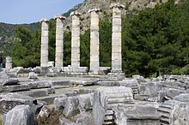
Pick up from your hotel or Izmir airport and morning departure for Priene, the Pompei of Anatolia and the first planned city of the ancient world. Visit the Theatre, the Temple Of Athena, the Pryaneum, the Agora, and the Altar Of Zeus and Cybele.

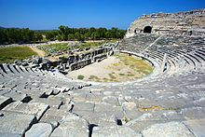
Proceed to Miletus, one of the principal Ionian cities and home of Thales which was twice visited by St. Paul. Visit the very well preserved Theatre, the Byzantine Fortress, the Delphinion, the Nymphanion, the Bouleterion, the Faustina Baths and the Mosque.

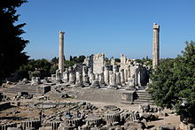
Then continue to Dydima visit the Temple of Apollo with its gigantic columns. Return back to Izmir after the tour. Drop off at your hotel or Izmir airport.

