Southern & East Africa’s Leading Destination Management Company

COMPANY PROFILE

INTRODUCTION
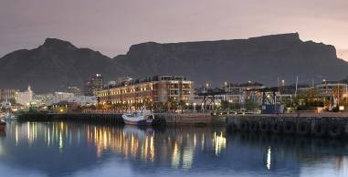
Dragonfly Africa Group has been involved in providing a wide range of services across a broad spectrum of tourism for 35 years.

Our main business is incoming tourism from all over the world in the form of individual travellers, groups, meetings, incentives, conferences and exhibitions. We are well known in the industry for our creativity and high levels of service.

Dragonfly Africa pioneered the extremely successful private game safaris / country hotel package combinations. We have expanded on these itineraries, offering exciting travel ideas which offer a blend of the best accommodation and services that Southern Africa has to offer.

In addition to our Travel Department, Dragonfly Africa has a large Meetings, Incentive, Conference and Events Division which creates exciting programmes for larger numbers. We employ a number of highly specialised staff who, together with our creative team, are able to produce original and spectacular proposals for small, exclusive groups of 20 participants to large groups of 500 - 2000 participants or more.

Dragonfly Africa was initially born out of the country hotel that the company owned - Cybele Forest Lodge & Health Spa. This hotel became the first ever Relais et Chateaux hotel in Southern Africa.

Throughout the 1980’s the travel business continued to expand and so moved its Head Office to Johannesburg, with an operations unit in Cape Town.

While South Africa experienced a change to a Democratic Government in 1994, the company saw additional opportunities in the MICE (meetings, conference, incentive & events) market and became involved with that from an early stage.

During 2010 Dragonfly Africa acquired 100% of Cape Town based competitor Green Route. This exciting development finalised the merger of two of Southern Africa’s leading Travel and Destination Management companies. With the acquisition of Green Route, The Dragonfly Africa Group has also invested in setting up Green Route East Africa. With an office in Nairobi, and now registered as a Kenyan Tour Operator, the East Africa office is well set-up to handle incentive programmes, conferences, and group and FIT bookings in Kenya, Tanzania, Uganda and Rwanda.

PROFILES

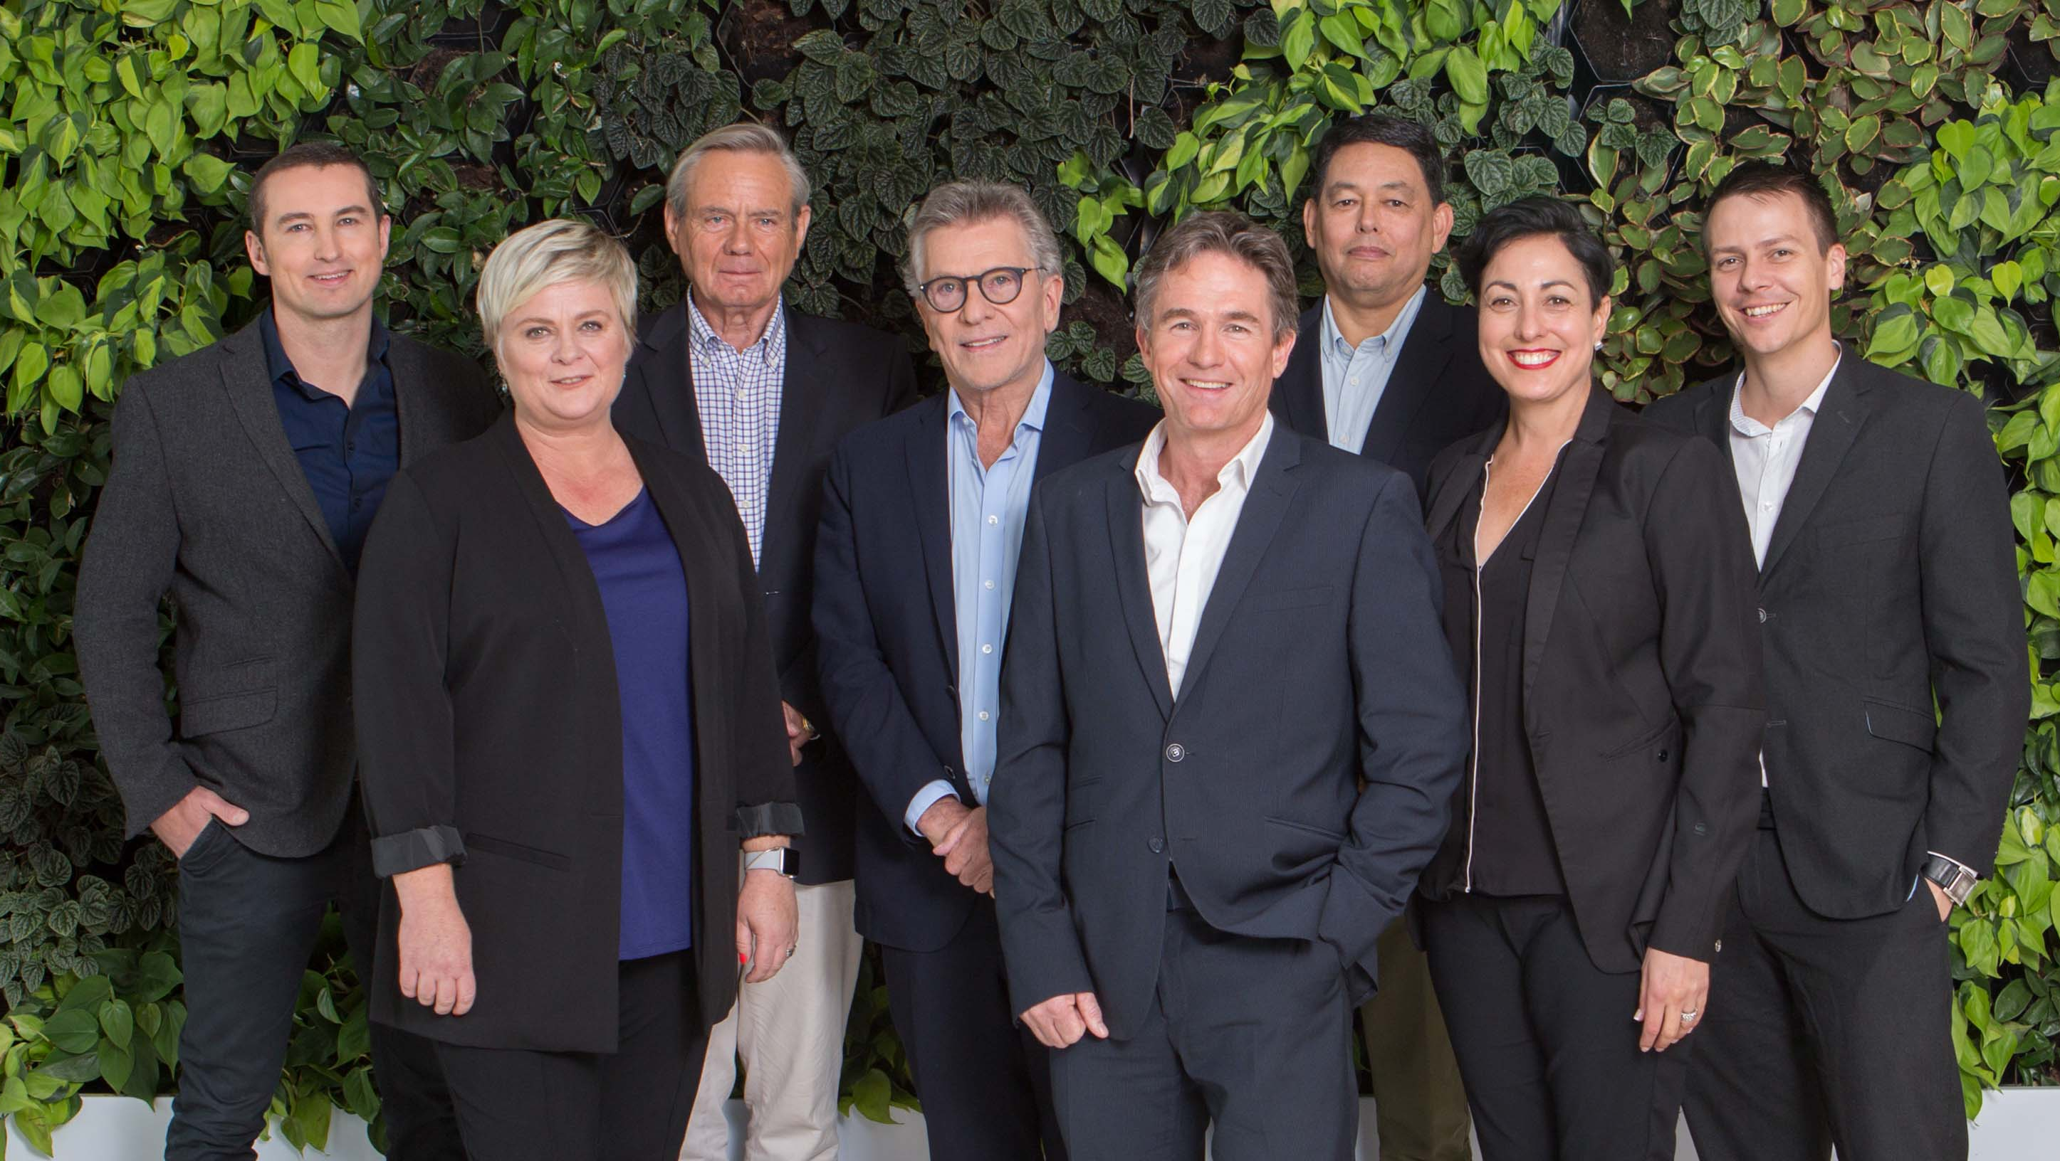
Rupert Jeffries, Executive Chairman
As Executive Chairman of two of the most established and successful destination management companies in Southern Africa - Dragonfly Africa - Jeffries has captured a significant slice of the high yield incentives market – a market virtually unknown in South Africa in 1994, when it all began. London-born Jeffries arrived in South Africa in 1975 as a Grey-Phillips advertising executive, fell in love with the country and made it his home. While still on international transfer in 1979, he visited Cybele Forest Lodge and Health Spa in Mpumalanga and after some soul searching, decided to buy it.

Whilst running Cybele, it occurred to Rupert that exploring the regions scenic beauty from the air might be of interest to guests. Dragonfly Africa gradually emerged from this foundation of helicopter adventure tours and South African combination travel packages.

Dragonfly Africa is involved in the following travel markets: USA & Canada, Australia & New Zealand, Brazil, Argentina & Mexico.The

Dragonfly Africa Group has achieved 10 SITE Crystal Awards, the equivalent of the Oscars, for the incentive market.

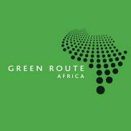

History of Green Route
Green Route was formed in 1991 and opened an office in Victoria Falls, Zimbabwe. The company was a pioneering force as a specialist Destination Management Company, firstly in Zimbabwe and then in all of southern Africa. Kerry Roos, the current Director, started working for Green Route in 1998. In 2001 she established the Green Route head office in Cape Town when it was moved from Victoria Falls. Kerry is now a Director and shareholder of Dragonfly Africa Group. In 1995 Green Route was awarded the first SITE Crystal Award in Africa, and this was the first of many accolades ahead.

Green Route Africa is involved in the following travel markets: United Kingdom, Benelux, Germany, France, Italy, Scandinavia, Singapore, Hong Kong and Poland.

MISSION STATEMENT

To provide our clients with a top-quality level of service resulting in an exceptional travel experience.

To demonstrate our creativity, innovation and commitment in a way which distinguishes us from others in the market place and leaves our clients with a strong feeling that they have received something special and memorable - something that represents value for money.

To build a team of knowledgeable, responsible, accountable and well-rewarded staff who are proud to be associated with the Group and who see a long-term future for themselves within the Group.

To carefully identify the markets or business areas that we wish to be involved with and to focus on these.

To build and sustain solid relationships with our clients and service suppliers.

To contribute meaningfully to the re-greening of Africa, and to help educate and develop and empower the local communities that we work within.

WHERE WE OPERATE

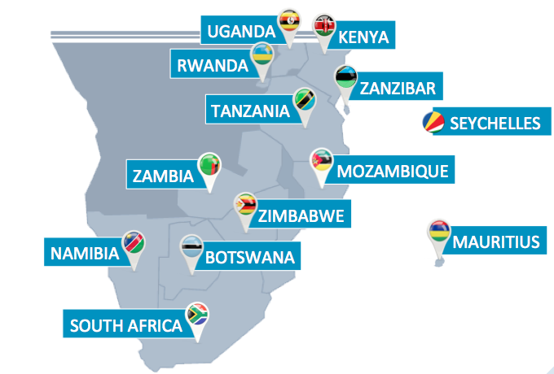

WHY CHOOSE SOUTHERN & EAST AFRICA?

Excellent meeting, conference and exhibition facilities

Magnificent scenery

Exceptional Safari / Wildlife experiences – The Big Five: Lion, Leopard, Elephant, Rhino and Buffalo (and the Small Five: Leopard, Tortoise, Ant Lion, Elephant Shrew, Rhino Beatle and Buffalo weaver!)

Five star hotels and first class service

Remarkable diversity of cultures, customs and languages

Temperate year round climate

Exceptional value for money

Daily non-stop flights from the USA, ex Atlanta, New York, JFK and Washington, Dulles and other international cities

Regular domestic air options - scheduled and charter

Direct flights from Brazil, Europe and Australia

Sophisticated cities

Excellent infrastructure including telecommunications and roads

Great food and wine

First class medical facilities

Luxury air-conditioned coaches

Professional, qualified foreign language guides and translation services when required

WHY CHOOSE green route?

Position in the Southern & East African Market
Green Route Africa is considered one of Southern & East Africa’s leading destination management companies.

We are acknowledged as the top South African company operating in the UK, Europe and Scandinavian markets.

After many years of involvement with traditional travel, and incentive, meeting and conference business, the Group is well known in the Southern African market.

Why our clients choose us
More often than not, we find ourselves in a competitive bid situation and, once a project has been awarded to us, we make it our business to find out why. Our main strengths are as follows:

Creativity / Research
We are well known for our creativity, and will continue to put forward practical and exciting ideas throughout the life of the project. We research new ideas and products on an ongoing basis and ensure that our staff and overseas sales offices are kept up to date with market developments.

Attention to detail
From the very beginning, we start to involve ourselves in detailed programme or itinerary planning which includes provision and planning for all contingencies.

Information
We want to make it easy for you to sell the destination to your client, so we will provide you with clear and motivating information and reasons for all aspects of the programme / itinerary proposed.

Keeping in touch
We believe in top rate service and will keep you in touch and informed throughout the project. We prefer to be asking you for answers rather than the other way around.

Buying Power
We have exceptional buying power within the Southern & East African market, due to volumes placed, and are treated with respect by the market.

We are always keen to negotiate added value for our clients, e.g. upgrades, additional free rooms, late check-outs, meeting rooms, the waiving of overtime fees, etc.

Relationships with Suppliers / Vendors
We have particularly strong relationships with all our suppliers, with whom we have worked for many years. Our company philosophy is to be respectful to all suppliers at all times, from the most senior to the most junior person.

As a result, it is a fact that suppliers enjoy working on Green Route Africa projects and appreciate our organizational ability which in turn makes their lives less stressful. Through these bonds, we are able to attain added attention and enthusiasm, and value when and where it really matters.

Financial Expertise
All our quotations are presented in a line by line, item by item format. This is very helpful for clients in arriving at a final budget, as items can be added or deleted. For a large project, it is usually our policy to bring accountants on site

to control the billing and to provide daily updates for the clients to sign off.

Green Tribe
Green Route Africa is a serious and early adopter of innovative and sustainable Corporate Social Responsibility Projects that may be integrated into programmes through our Green Tribe initiative, a registered Section 21 Company (not for profit).

Operational skills
We are experienced in meeting individuals on arrival at airports and in managing and controlling large groups, including those with multiple airport arrivals. We have the facility to meet clients at the door of the aircraft and fast track them through immigration. We are used to having back up plans and to having plans changed at the last moment.

We have an excellent team of professionals and experienced people who are all given specific tasks during an incentive or conference programme.

We have a large network of very experienced guides and tour directors who have worked on previous projects with us and who understand exactly how we operate and what is required of them.

Expertise in pre and post extensions
With our Travel Department, we specialise in extensions and regularly co-ordinate and manage pre and post tours for our clients, including website links, as many of our clients arriving from around the world for an incentive, meeting, or conference, want to see more of the country.

Staff Long Service
We have a history of staff stability. For example 36 years service for our Executive Chairman, 24 years for our Senior Operations Manager, 20 years for our Financial Director, 18 years for our CEO, and 15 years for our Sales and Marketing Director.

Air Charter
The company specialises in helicopter and fixed wing air charter – from Cessna and Beechcraft to Boeing and Airbus. We are able to source the most competitive rates and provide clients with full aircraft documentation including of course insurance cover.

Coach Charter
We have been associated with our preferred coach company over many years. They have a modern fleet with a variety of vehicles from Quantums, to 22-seater and 44-seater luxury coaches. The latter with an onboard fridge, restroom and P.A system.

The drivers are all well trained and extremely courteous.

VIP Vehicles
We have superb vehicles available for transfers and tours – from the top of the range BMW’s to 9-seater luxury Hyundai’s. All our drivers are experienced South African Tourism registered driver/guides, and our Johannesburg drivers have completed BMW advanced driving courses.

Duty Officer
We have a 24-hour duty officer on call 365 days of the year.

Production, Design Services & Photography
Green Route Africa has an associate division that specialises in conceptual design for ideas, themes and production for motivational programmes. From initial communication through to all on site material and branding. Gifting, professional photography and videography are also areas in which we specialise

NAME | TITLE | YEARS OF SERVICE
Rupert Jeffries | Executive Chairman | 36 Years
Lucy Quinan | Senior Manager: Operations | 26 Years
Barry Schreiber | Chief Financial Officer | 22 Years
Michael Waller | Chief Executive Officer | 19 Years
Kerry Roos | Director: Incentives & Travel Green Route Africa | 18 Years
Yolanda Woeke-Jacobs | Vice President: Sales and Marketing | 16 Years
Milva Grispo-Lopes | Leisure Manager | 15 Years
Bonny Robb | General Manager: Green Route Africa | 15 Years
Mary Mileham | Executive Assistant | 14 Years
Cynthia Ngcwana | Reception | 14 Years
Sylvia Phaswana | Reception | 12 Years
Sheetal Vallabh | Senior Leisure Specialist | 11 Years
Clinton Els | Director: Incentives & Travel Dragonfly Africa | 10 Years
Debbie Holmes | Director: MICE Operations | 10 Years
Lesley Davie | Finance Controller | 10 Years
Marnelda Steyn | Senior Incentive Account Manager | 9 Years
STAFF TENURE: DRAGONFLY AFRICA & GREEN ROUTE AFRICA
5 YEARS AND OVER – APRIL 2018

5 YEARS AND OVER

NAME | TITLE | YEARS OF SERVICE
Thomas Makathi | Manager: East Africa | 8 Years
Johan Van Wijk | Director: Group Finance | 8 Years
Rachel Lifuwa | Travel Assistant | 7 Years
Jessica Kanumubadi | Account Manager | 7 Years
Nwabisa Aaron | Personal Assistant | 7 Years
Ilyaas Narker | Group Sales Manager | 6 Years
Silvia Tevez | Senior Account Manager | 6 Years
Shereen van Dyk | Bookkeeper | 5 Years
Clare de Haas | Manager: Operations & Administration | 5 Years
Shihaam Fakier | Manager: Incentives & Administration | 5 Years
Eleanor Scipio | Bookkeeper | 5 Years
Antoinette du Preez | Group Sales Manager | 5 Years
David Msibi | Registered Guide | 5 Years

Our Professional partners

Bankers
Company: Nedbank - Sandton City Branch
Contact person: Cheryl Dashwood – Private Banker
Telephone: +27 11 775 2822
Fax: +27 11 883 9030
Address: Block 1, Upper Ground Floor, 135 Rivonia Road, Sandton
Email address: cheryld@nedbank.co.za
Years of service: 17 years

Auditors
Company: KPMG (previously Deloitte & Touche)
Contact person: Jeremy van Niekerk
Telephone: +27 13 752 7131
Fax: +27 13 752 6357
Address: 5th Floor, The Pinnacle Building, Nelspruit, Mpumalanga
Email address: jeremy.vanniekerk@kpmg.co.za
Years of service: 25 years

Attorneys
Company: Werksmans Attorneys
Contact person: David Hertz / Trevor Boswell / Bulelwa Mabasa
Telephone: +27 11 535 8000
Fax: +27 11 535 8600
Email address: dhertz@werksmans.com / tboswell@werksmans.com / bmabasa@werksmans.com
Address: 155 – 5th Street, Sandown, Sandton, Johannesburg
Years of service: 18 years

Advertising Agency
Company: Brand Industry
Contact person: Graham Taylor
Telephone +27 11 467 6561/2
Fax: +27 11 467 6684
Email Address: graham.t@brandindustry.co.za
Address: Block D Lonehill Office Park, Lonehill Boulevard, Johannesburg
Years of service: 18 years

CONTACTS
CAPE TOWN

Bonny Robb
Tel: +27 (0) 21 658 6800
Fax: +27 (0) 21 685 0028
Email: info@greenroute.co.za

JOHANNESBURG

Clinton Els
Tel: +27 (0) 11 219 5600
Fax: +27 (0) 11 268 2010
Email: info@dragonfly.co.za

NAIROBI, KENYA

Thomas Makathi
Tel: +254 (0) 738 334723
Email: thomasm@greenroute.co.ke

BENELUX

Raymon Honing (Travelmediate)
Tel: +31 20 260 00 53
Email: info@travelmediate.nl

UNITED KINGDOM

Henriette Attard
Tel: +44 (0) 20 8994 2308
Email: henriette@justtheletterb.com

SCANDINAVIA

Natasha Flodin
Tel: +46 (0)76 318 88 02
Email: info@travelcollection.se

In the words of our clients

Green Route’s attention to detail is like none I have seen before. You cared for my group even better than I would have. Few, if any, of the DMCs with whom I work offer a resource of your calibre. I will have to re-adjust my expectations and mindset for next year’s trip. My “new plan” is to only take my group to destinations where Green Route has a presence!
MW
ACI, USA

The Green Route team was brilliant. Organisation was slick, creative and requests were always met with a smile, no matter how demanding. I can’t wait to work with you guys again.
CS
United Kingdom

A pleasure to work with such professionals in South Africa! Great feedback from delegates – 10 out of 10 for most things from an incentive experience that worked like clockwork.
FM
United Kingdom

Our clients are over the moon …marvelled … amazed with their experiences (Victoria Falls and Chobe Safari) and have congratulated the Green Route team. Thanks to you all for your work, kindness, great listening and adaptation to changes. The clients are enchanted. And so are we!
M LF
France

We set some tough objectives for the XK global launch in Cape Town. We met them; generated the most positive media covered

ever for a Jaguar and delivered the best media launch I have ever seen in over a decade of launches. That is not just our opinion – we have had hundreds of journalists from all over the world tell us just that! The passion, dedication and hard work of the Green Route team really made a difference and this is much appreciated. You did a simply superb job for us.
SD
United Kingdom

The global media launch of the new XK Coupe and Convertible in Cape Town has been one of the very best in the history of the company. Thank you for the Green Route team’s hard work and dedication. There was a can-do attitude that was all-pervasive.
I am delighted that so many journalists have taken the time to say this is the finest press launch they have attended. You can be proud of your impact on this launch.
JW
United Kingdom

Nice to hear from my client that their trip was the best ever! Working with Green Route is always a privilege and a pleasure.
JV
South Africa

Quite simply, Green Route was superb – the best ground team I have ever worked with. Exemplary management, tireless troubleshooting, passion and attention to detail and the brilliant handling of the guests were phenomenal to behold. We were genuinely blown away with Green Route’s delivery and consider it a privilege to have been part of something so special.
NP
United Kingdom

In the words of our clients

Thank you for an outstanding job. Your professionalism and positive can-do attitude was simply first class and made the trip to South Africa resounding success.
RF
Europe

To say the IBM event was extraordinary is an understatement! Most of the credit begins and ends with Green Route … starting with your vision, enthusiasm and love of the incentive business and continuing with the creativity and hard work during the planning process, and ending with the attention to detail and dedication on site that made it all come together so perfectly. Rates their best incentive ever!
KH
USA

What a fantastic trip and once again it has been a pleasure working with Green
Route in Victoria Falls and Sun City. Thank you, thank you and thank you again!
JP
United Kingdom

Brilliant job in Cape Town with plenty to enthuse a high profile client with high expectations. Your team was so positive, knowledgeable and enthusiastic.
CM
United Kingdom

Thank you once again for all the excellent job that Green Route team did in Cape Town.

We´ve got some positive feed-back from the client and they seem to be very pleased with the logistics, the excursions and the whole trip actually.
MS
Sweden

I can’t thank you and the team enough for your amazing efforts over the last few months pulling our events together for our clients. The guests have been totally amazed by the organisation and delivery of the programme.

We have really enjoyed working with you and I hope we get another enquiry for SA very soon!
RD
United Kingdom

Our Client List

Since inception Green Route Africa has operated some of the top global companies from around the world. Our expertise for handling both intimate groups of 10 delegates to groups of over 1000 delegates has afforded us an enviable client list of which below is just a snapshot.

A
AB BEV, 2017, UK
ABBEY, 2008, UK
ACI Worldwide, 2007, USA
ACS, 2016, UK
AEROCLUB, 2007, Russia
AIMS INT’L, 2008, Europe
AKZO NOBEL, 2015, UK
AMACO, 2008, Australia
AMGEN, 2010, UK
AMICUS, 2008, Australia
AMP, 2008, UK
ANCIENT BRITONS, 2008, UK
ASTELLA, 2015, UK
ASTURIENNE, 2007, Europe
AUDI AUSTRALIA, 2010, Australia
AVCA, 2014, UK
AVCA, 2016, UK
AVON, 2007, UK
AXA SUN LIFE, 2009, UK

B
BANK OF AMERICA, 2015, USA
BANK OF AMERICA, 2016, USA
BAT, 2007, UK
BELRON, 2007, UK
BELRON, 2012, UK
BELRON, 2015, UK
BELRON, 2016, UK
BERGERAT MONNOYEUR, 2008, UK
BIC, 2013, EUROPE
BIOGEN GROUP, 2011 & 2014, UK
BKR, 2008, USA
BLACKBERRY, UK, 2013
BMW, 2007, UK
BOSE, 2011, Benelux
BRICKWORKS, 2011, Australia
BRITISH AMERICAN TOBACCO, 2017, UK
BPI, 2008, Europe
BRITISH TELCOM, 2009, UK
BUPA, 2016, UK

C
CA ALSACE VOYAGES, 2011, Europe
CAMLOG, 2013 & 2014, EUROPE
CANON, 2007, Australia
CANON, 2008, UK
CATERPILLAR, 2009, Dubai
CARGLASS, 2007, Europe
CFAR, 2011, USA
CICERON, 2013, EUROPE
CITROEN, 2011, Europe
CITROEN, 2017, Belgium
CLIP DISPLAY, 2008, UK
CONOCO PHILLIPS, 2007, UK
CONFERENCE GROUP, 2010, UK
CPA INTELLECTUAL PROPERTY, 2017, UK
CSF, 2008, UK
CSF, 2008, UK

D
DAF TRUCKS, 2008, UK
DATATEC, 2007, South Africa
DELL, 2014, UK
DENTAL ASSOCIATION, 2016, EUROPE
DERMALOGICA, 2013, EUROPE
Duracell, 2018, Brazil

E
ESSILOR, 2013, EUROPE
EUROPEAN DELEGATION, 2010, Europe

F
Fenix, 2018, UK
FREEMAN FOX, 2007, Australia
FIAT, 2007, UK
FIAT, 2017, UK

G
GAVI ALLIANCE, 2012 UK
GANNET, USA, 2013
GE HEALTHCARE, 2007, UK
GERMAN GOVT, 2007, Europe
GERMAN VIP, 2007, South Africa
GERMAN DELEGATION, 2008, Europe
GEH, 2008, Germany
GERMAN DELEGATION, 2015, EUROPE
GID GROUP, 2008, Australia
GILEAD, 2015, UK
GENERAL MOTORS, 2007, South Africa
GENERAL MOTORS, 2008, Mexico
GSK, 2013, EUROPE

H
HA, 2008, South Africa
HANSARD, 2007, UK
HEINEKEN, 2016, SOUTH AMERICA
HENRY SCHEIN, 2007, UK
HONDA, 2016 UK
HIPRA, 2015, EUROPE
HP, 2008, Australia

I
IARLJ, 2009, Australia
ICEFAT, 2009, Europe
IKO, 2017, UK
IT Group, 2008, UK
IT, 2009, UK

J
J&J, 2009, UK
J&J, 2011, UK
JIG WORKSHOP, 2016, UK

K
KENES, 2015, EUROPE
KIA, 2016, UK
KGO RADIO, 2007, USA
KONICA MINOLTA, 2014, UK

L
LANDMARK, 2008, UK
LOGICALIS, 2007, UK
LUCOZADE, 2017, UK

M
MARY KAY, 2007, ASIA
MARY KAY, 2017, Sweden
MAZDA, 2016, UK
MERCK SERONO, 2008, Dubai
MERILL LYNCH, 2008, UK
MERITUM FINANCIAL CONF, 2009, Australia
MINI, 2016, UK
MORTGAGE CHOICE, 2007, Australia
MOUNTAIN EVENTS, 2008, Europe
Mt KILI CHARITY GROUP, 2011, Australia

N
NEW HOLLAND, 2007, Europe
NORWICH UNION, 2008, UK
NOKIA, 2011, UK
NOVATIS, 2017, Europe
NUMARK, 2017, UK
NU SKIN, 2017, UK

O
ORANGE, 2008, UK
ORASURE TECHNOLOGIES, 2010, UK

P
PEL LEADERS – GROUP 1, 2011, Europe
PEL LEADERS – GROUP 2, 2011, Europe
PEPFAR, 2011 & 2104 USA
PEUGEOT, 2017, UK
PHARMA GROUP, 2011, Europe
PLATINUM 2010 BRICKWORKS, 2011, UK
POLYPIPE, 2016, UK
PRESIDENTS CLUB, 2007, UK
PRESIDENTS CLUB, 2008 ,UK PRUDENTIAL, 2008, UK
PULSE RECRUITMENT, 2011, UK

R
RECM, 2007, SA
RECTICELL, 2009, Europe
RENAULT, 2017, Poland

RICOH, 2012, UK
ROBERT WALTHERS, 2008, UK
ROBERT WALTHERS, 2013, UK
ROBERT WALTHERS, 2015, UK
ROLLS ROYCE, 2017, UK

S
SAB CROWN MILLER, 2013, UK
SAMSUNG, 2015, UK
SANOFI, 2008, Switzerland
SAX CLUB, 2007, Canada
SCANIA, 2014, UK
SCAN SOURCE, Brazil, 2017
SCOTTISH WIDOWS, 2008, UK
SCOTTISH LIFE, 2008, UK
SCOTTISH LIFE, 2011, UK
SCHWARZKOPF & HENKEL, 2011, UK
SIRIUS, 2011, UK
SMILING STARS, 2010, UK
SONY, 2010
STARWOOD ELITE, 2007, Singapore
STARWOOD, 2007, Singapore
STARWOOD, 2007, Latin America
STRYKER, 2014, UK
SUNGLASS HUT, 2014, 2015 & 2016, SOUTH AFRICA
SWIFT, 2008, Europe
SWIFT, 2010, Benelux
SYNTER, 2013, UK

T
T MOBILE, 2007, UK
TARKETT, 2017, UK
TFI, 2014, UK
THE JOURNEY, 2007, UK
THE JOURNEY, 2008, UK
THOMAS REUTERS, 2017, UK
TOYOTO, 2014, UK

U
UNUM PROVIDENT, 2007, UK
UNCONVENTIONAL CONVENTIONS PRE TOUR, Australia

V
VEXIM, 2016, EUROPE
VIRGIN MEDIA, UK, 2014
VW ZAMBIA, 2008, UK
VW, 2008, Europe
VODAFONE, 2009, UK
VOLVO, 2016, EUROPE

W
WCA, 2008, Europe
WCA, 2008, UK
WCA, 2008, Europe
WELLA, 2008, UK
WHARTON UNIVERSITY, 2008, Australia
WORLD VENTURE FIELD, 2017, UK
WOW TRAVEL, 2008, UK
WUERTH, 2008, Germany

X
XENON, 2015, UK
XEROX PREMIER CLUB, 2008, UK
XEROX HONOURS CLUB, 2008, UK

Y
YELLOW FISH, 2009, UK
YUM, 2015, USA

Z
ZURICH, 2008, UK
118 MEDIA, 2008, UK

FUTURE GROUP, MEETING, INCENTIVE AND CONFERENCES CLIENT LIST:

AVCA, 2018 UK
Rentokil, 2018 UK
Landrover, 2018 UK
NPO, 2018 UK
Nikkon, 2018 UK
Japtur, 2018 Brazil
Mclaren, 2018 UK

