Talking Stick Global

The Africa Portfolio Summer 2025

Portfolio updated May 2025

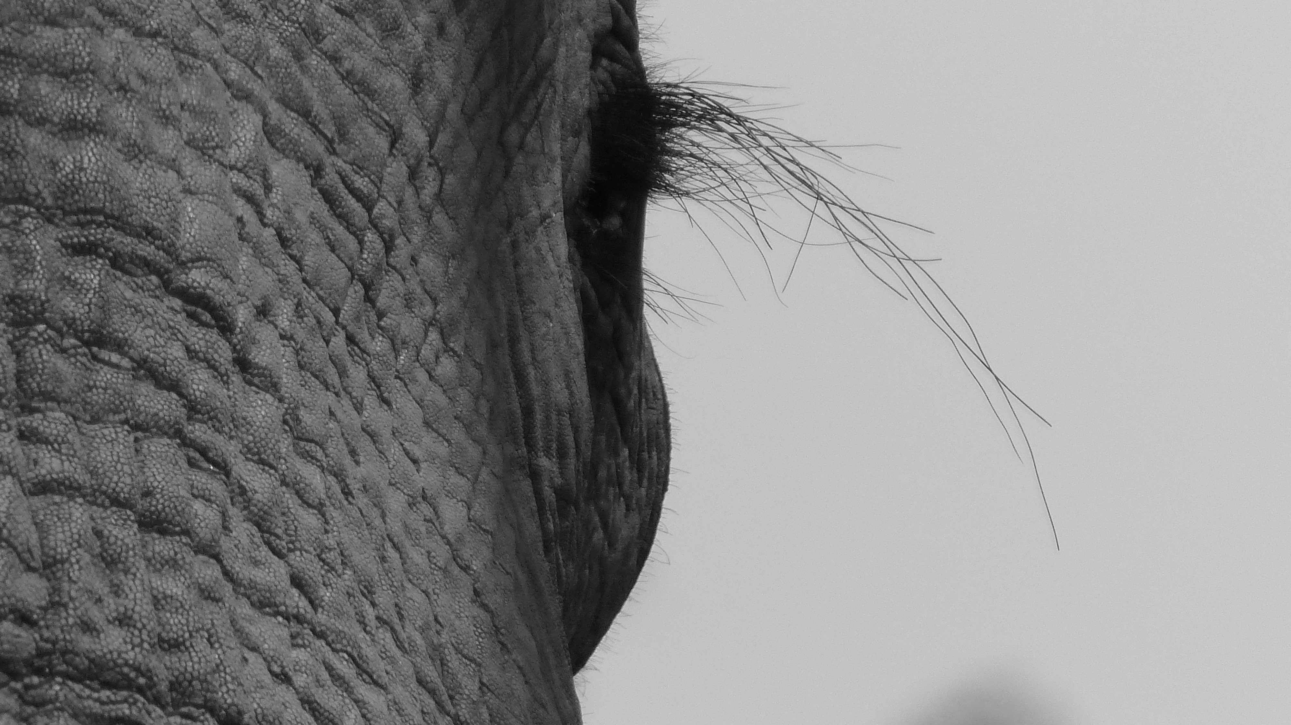

Title

# Our portfolio consists of the finest Hotels, Safari Lodges, Tented Camps a leading Airline and Destination Management Companies throughout Africa.

**Game lodges, Tented Safari Camps and Hotels and Destination Management Companies.**

* [Oceana Beach and Wildlife Reserve](https://www.google.com/url?sa=t&rct=j&q=&esrc=s&source=web&cd=&cad=rja&uact=8&ved=2ahUKEwjAvoiikPL9AhUIJ8AKHRrdAaEQFnoECA4QAQ&url=https://oceanareserve.com/&usg=AOvVaw2Fvm_D8WQv5E9NeGgbdxKn), Situated in Eastern Cape **South Africa** offering both a beach and wildlife experience.
* [Legacy Hotels and Resorts](https://www.google.com/url?sa=t&rct=j&q=&esrc=s&source=web&cd=&cad=rja&uact=8&ved=2ahUKEwiAy4DtlfL9AhWIglwKHR0kBboQFnoECCkQAQ&url=https://www.legacyhotels.co.za/&usg=AOvVaw1wSg0JH4f5Oi8FoNHVJawv), City hotels and luxury lodges throughout the main tourist areas of **South Africa** and **Namibia**
* [Kruger Untamed](https://www.googleadservices.com/pagead/aclk?sa=L&ai=DChcSEwi8kY6QuYGAAxWa1e0KHWxKDD0YABABGgJkZw&ae=2&ohost=www.google.com&cid=CAASJeRoCw6Id7ziMtkQWwBTlVPUmcpB-94stJ7rkMOofotT9wThoKw&sig=AOD64_3UHHz5w9GpsQXAR9kaKDKkX-gydQ&q&adurl&ved=2ahUKEwiljoeQuYGAAxWNaMAKHVpeBycQ0Qx6BAgJEAE) and [Chiefs Tented Camps](https://www.google.com/url?sa=t&rct=j&q=&esrc=s&source=web&cd=&cad=rja&uact=8&ved=2ahUKEwjR1ZiiuYGAAxWsUkEAHdAJAiwQFnoECBEQAQ&url=https%3A%2F%2Fchiefstentedcamps.co.za%2F&usg=AOvVaw3s6_XDIsFC6PZwLLM_GHlF&opi=89978449) Private luxury tented camps within the **Kruger National Park** **South Africa**
* [Kruger Shalati](https://www.google.com/url?sa=t&rct=j&q=&esrc=s&source=web&cd=&cad=rja&uact=8&ved=2ahUKEwjO6be5uYGAAxVQTkEAHaSDDhUQFnoECBEQAQ&url=https%3A%2F%2Fwww.krugershalati.com%2F&usg=AOvVaw0iAD23el7LSmLZhM4_MZ2L&opi=89978449) “the train on the bridge” the iconic train hotel on the Crocodile River within the **Kruger National Park** **South Africa**
* [Sanctuary Mandela](https://www.google.com/url?sa=t&rct=j&q=&esrc=s&source=web&cd=&cad=rja&uact=8&ved=2ahUKEwjY4qL_oIuAAxWUTkEAHdHnD_gQFnoECA8QAQ&url=https%3A%2F%2Fwww.sanctuarymandela.com%2F&usg=AOvVaw1SCaMlxLusbGGTBrkyD7xW&opi=89978449) the former residency of Nelson Mandela now a boutique luxury hotel, **Johannesburg** **South Africa**
* [Bayala Private Safari Lodges](https://bayalagamelodge.co.za/) situated just 3 hours north of Durban in the **Zuka Game Reserve, South Africa**
* [The Palm River Hotel](https://www.googleadservices.com/pagead/aclk?sa=L&ai=DChcSEwjJlpOplvL9AhXM3-0KHZuyBlUYABAAGgJkZw&ae=2&ohost=www.google.com&cid=CAASJORo0jfocAEgbpA_DCS7x7bYLOFSfO7FxFzWKV6VOTvnlBrZVg&sig=AOD64_0MacTDDH7eIc4RSsiKDHxf-o2CQw&q&adurl&ved=2ahUKEwjG7oqplvL9AhVhRUEAHdtsDQQQ0Qx6BAgJEAM), Victoria Falls, **Zimbabwe**
* [The Ilala Lodge Hotel](https://www.googleadservices.com/pagead/aclk?sa=L&ai=DChcSEwj1k4PLlvL9AhUOme0KHQgTDxUYABACGgJkZw&ae=2&ohost=www.google.com&cid=CAASJORoS-xLjqsKY-wwuKVRVbng1Cg9OYDwpanHLYFtZbVsf9-l1w&sig=AOD64_3eeDkbjeBwg9MfGHrEpfGeer7wEg&q&adurl&ved=2ahUKEwiMw_3KlvL9AhUJilwKHYbDD2EQ0Qx6BAgJEAE), Victoria Falls, **Zimbabwe**
* [The Amalinda Collection](https://www.amalindacollection.com/). The Hwange and Matopo’s National Parks, **Zimbabwe**
* [Shearwater Adventures](https://www.shearwatervictoriafalls.com/) , Victoria Falls activities and accommodation, **Zimbabwe**
* [Cresta Mowana Safari Lodge](https://www.crestamowana.com/) situated on the banks of the Chobe River bordering the **Chobe National Park** **Botswana**
* [Wild Frontiers Camps and Lodges](https://www.google.com/url?sa=t&rct=j&q=&esrc=s&source=web&cd=&cad=rja&uact=8&ved=2ahUKEwiHvenllvL9AhUYNcAKHQT5AK8QFnoECAoQAQ&url=https://www.wildfrontiers.com/our-camps/&usg=AOvVaw2epu5vrvN4yfDk--ZqGs3_) **Uganda** and **Tanzania** lodges and tented camps and a boutique hotel. **Uganda** and **Tanzania** based Destination Management

**Destination Victoria Falls, Africa’s MICE Capital**

Launched in May 2025 Destination Victoria Falls is targeted at the MICE market is a collaboration between Shearwater Adventures, Queen Nandi Place Conference Centre, Chiefs Tented Camps and The Palm Hospitality Group

THE AFRICA PORTFOLIO



We are a family business with our roots in the tourism and hospitality industry. We pride ourselves on taking time to fully understand our clients product, and work with them as an extension of their company within the United Kingdom and Ireland. During our 18 years in business this has resulted in long-term relationships with clients whose brands we love and the travel trade which support them.

Originally established as a “traditional representation company” we have evolved into a multi-faceted tourism marketing agency. Offering our clients, representation, digital marketing, creative design, photography and film all related to and dedicated to tourism promotion.

[WWW.TALKINGSTICKGLOBAL.COM](http://WWW.TALKINGSTICKGLOBAL.COM)